GARAGE MANAGEMENT APPLICATION:

College name: Pioneer College of Arts and Science

College code:4d

Team ID:

Team Members:

1.Team Leader: Rithika TS

Email: [rithikasenthil176@gmail.com](mailto:rithikasenthil176@gmail.com)

2.Sunitha M

Email: [sunithamsunitha28@gmail.com](mailto:sunithamsunitha28@gmail.com)

3.Priyadharshini A

Email:priyadharshinianandhan.2005@gmail.com

4.Kulanthai Samy S

Email: [ajaysamraj23@gmail.com](mailto:ajaysamraj23@gmail.com)

1.INTRODUCTION:

1.1 Project Overview:

The Garage Management System is a valuable tool for automotive repair facilities, helping them deliver top-notch service, increase operational efficiency, and build lasting customer relationships. With its user-friendly interface and powerful features, GMS empowers garages to thrive in a competitive market while ensuring a seamless and satisfying experience for both customers and staff.



1.2 Purpose:

The purpose is to digitize and streamline all aspects of an auto repair shop's operations, from appointment scheduling and customer communication to inventory management, invoicing, and tracking vehicle histories.

DEVELOPMENT PHASE

Creating Developer Account:

By using this URL - <https://developer.salesforce.com/signup>

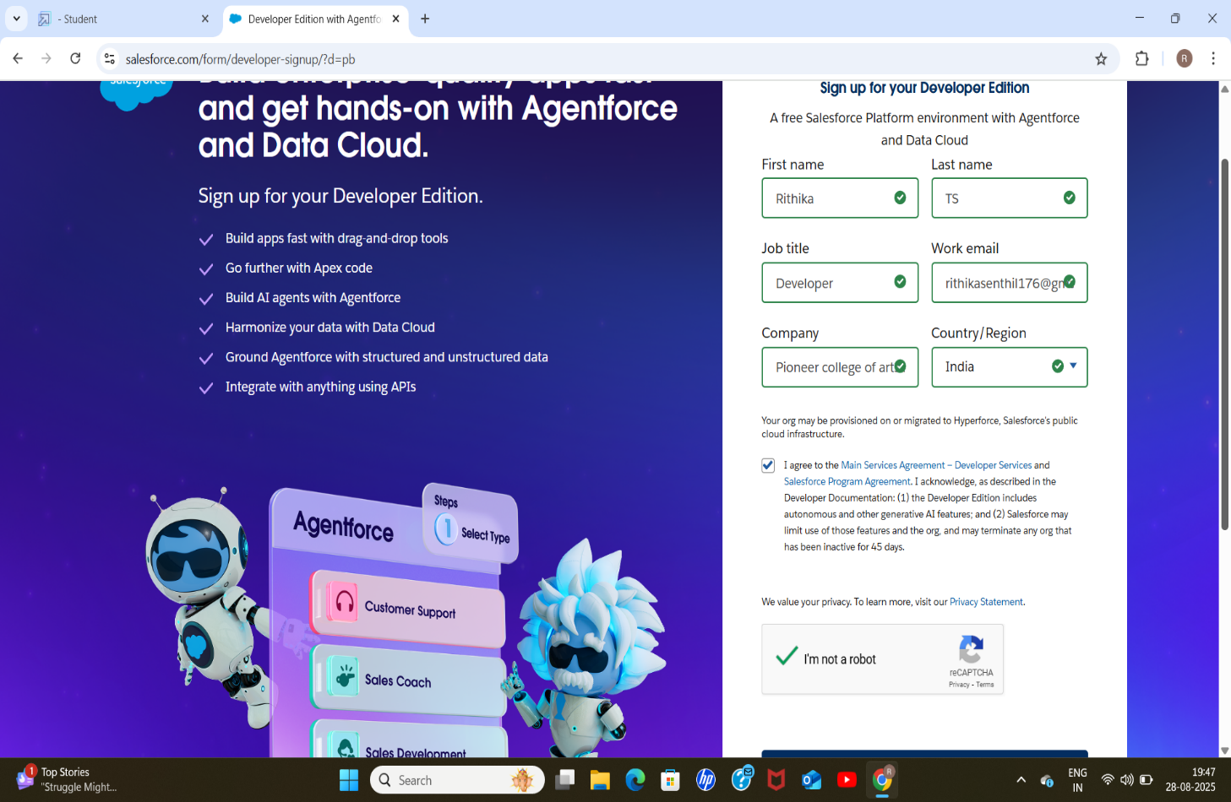

Created objects: Customer details, Appointment, Service records, Billing details and feedback.

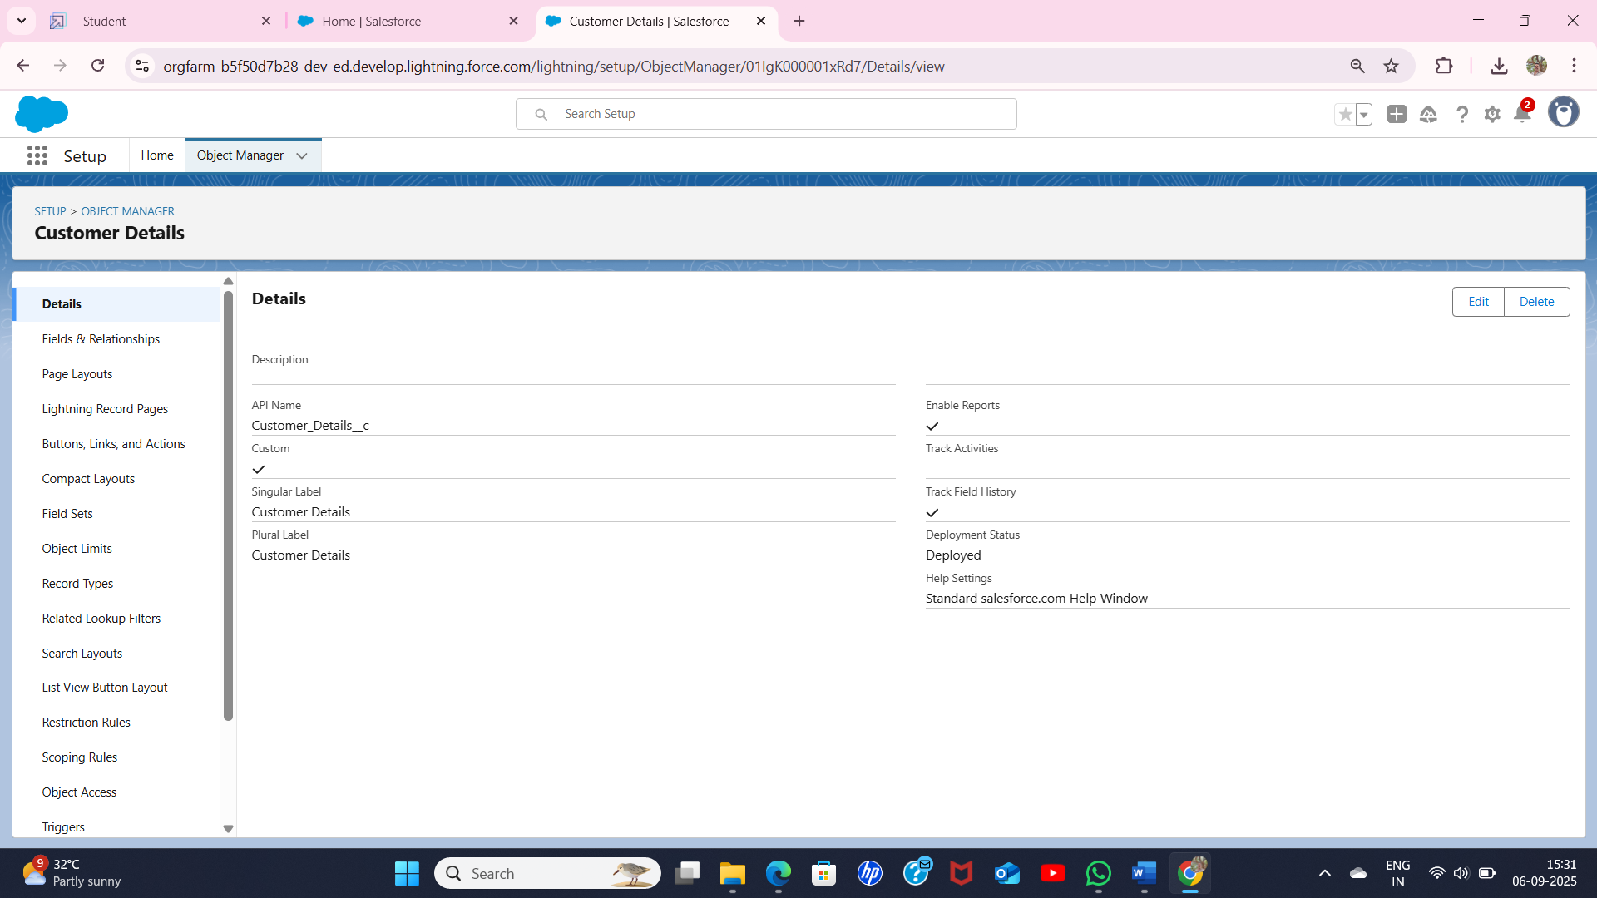

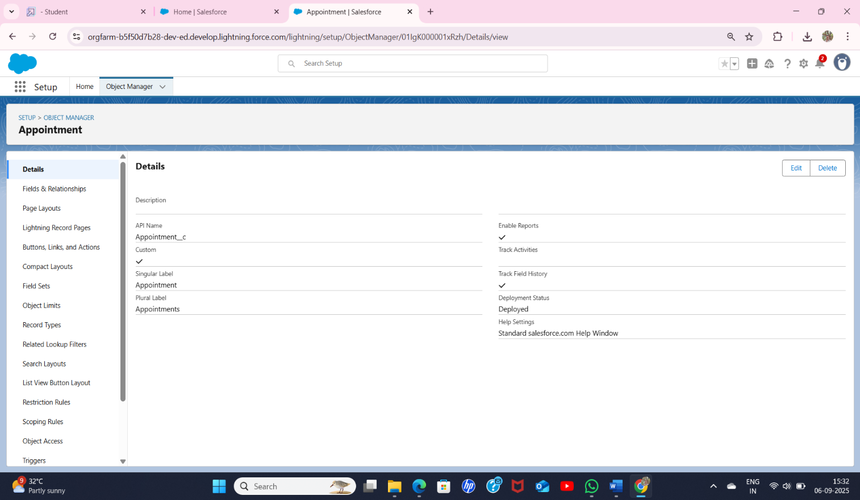

* 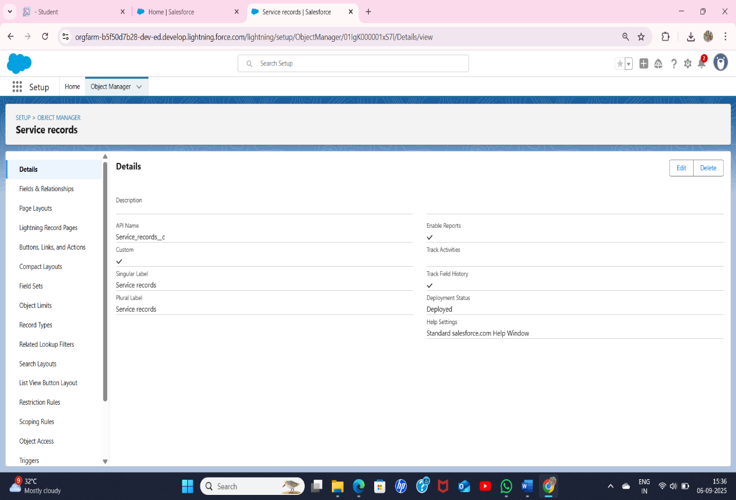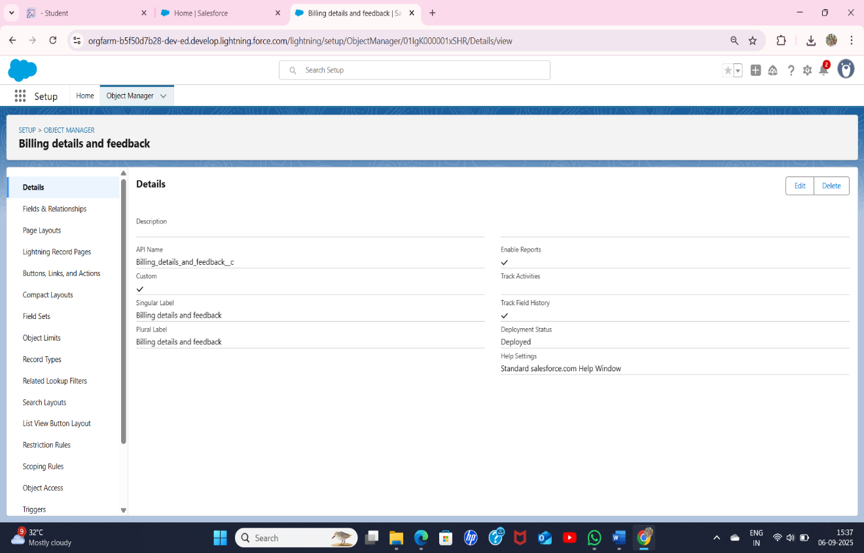 Creation of fields for the Customer Details object, Lookup field, Checkbox fields, Date fields, Currency field, Text field, Picklist field, Formula field in Service Records objects.

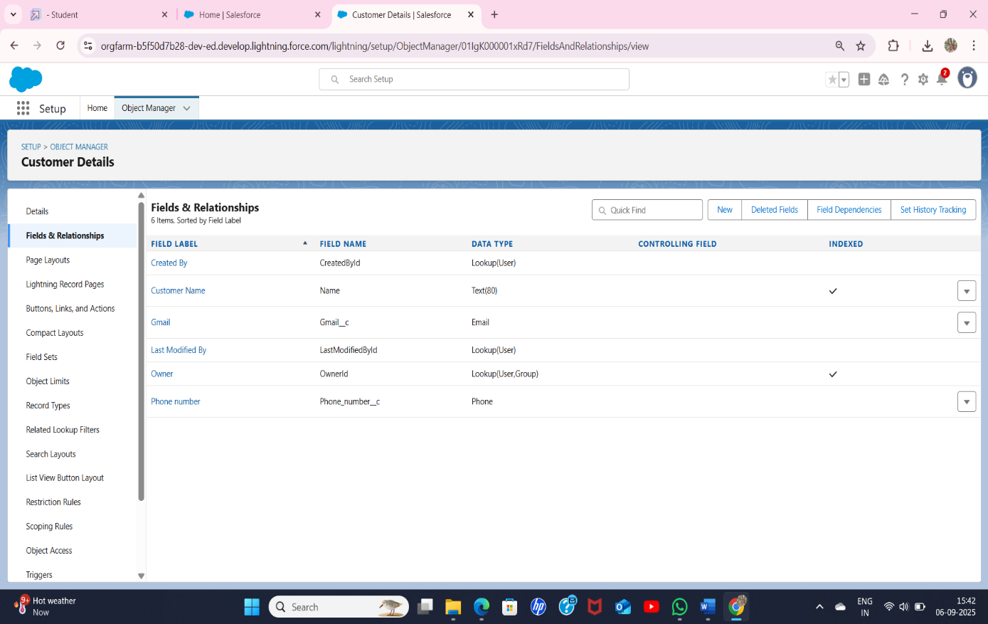

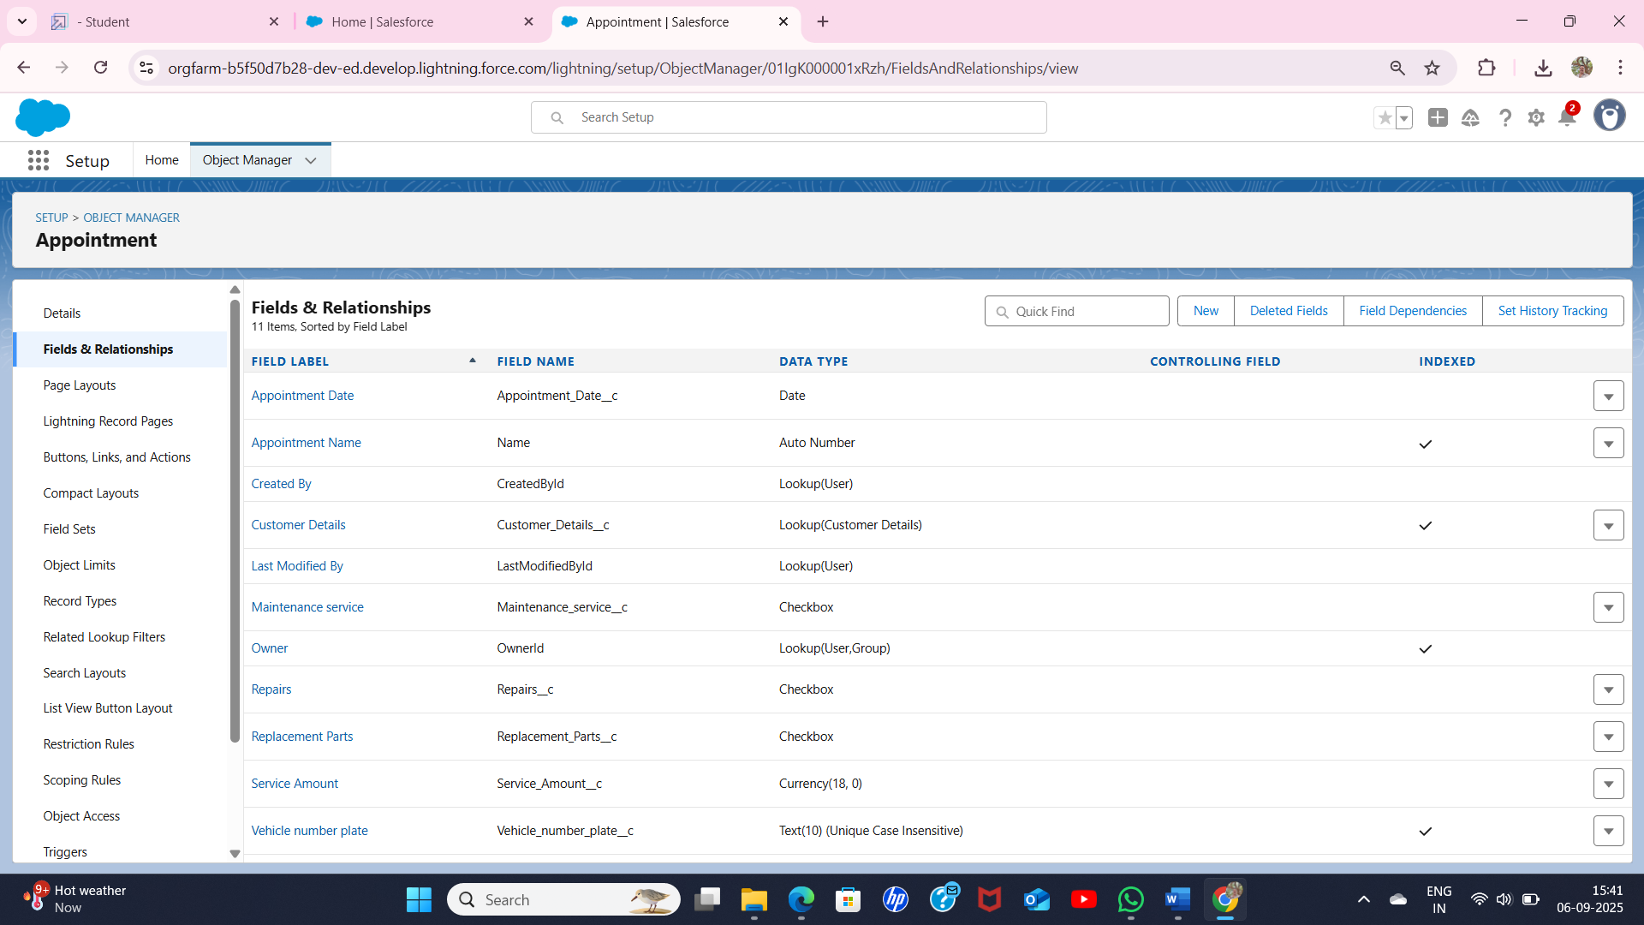

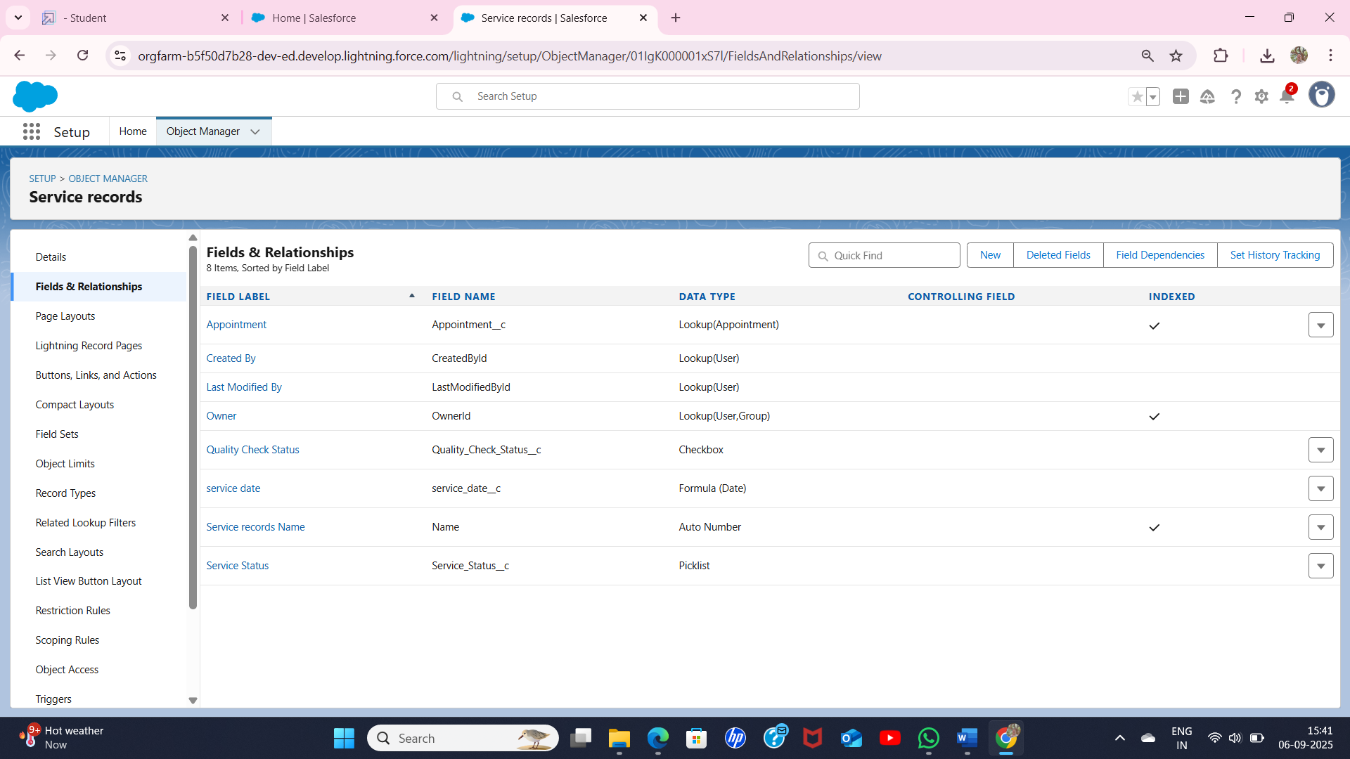

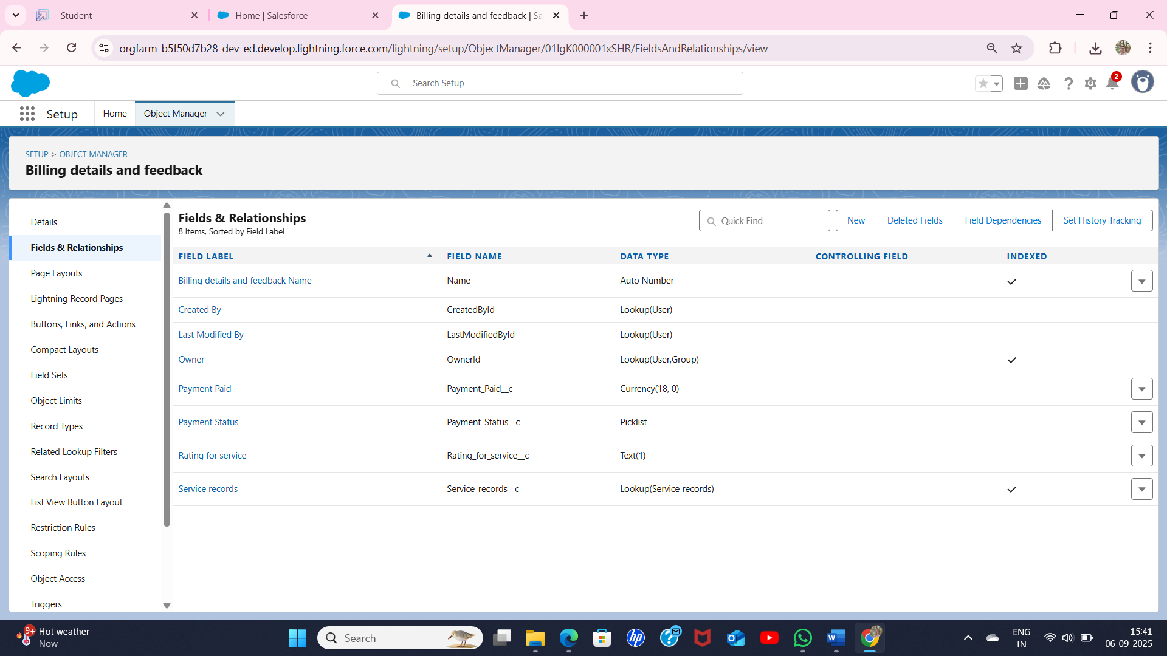

* Developed Lightning App with relevant tab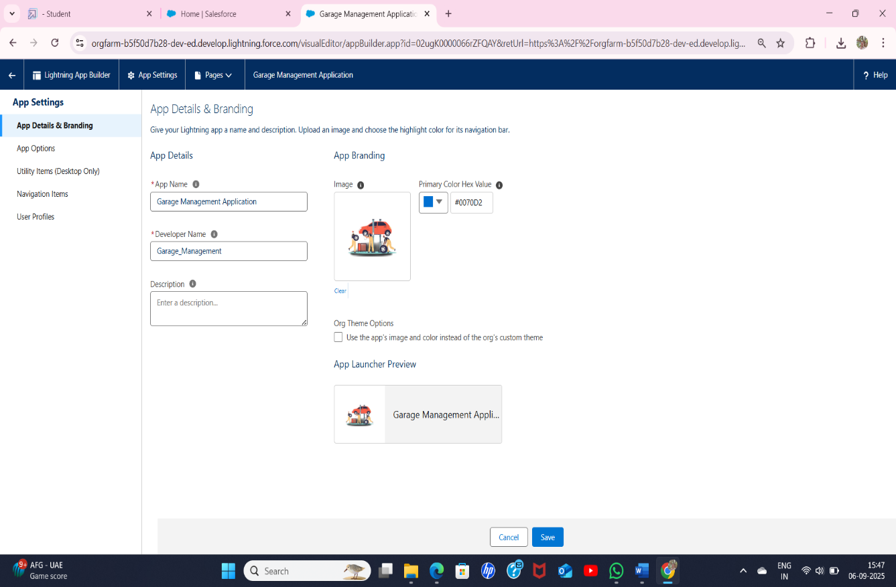

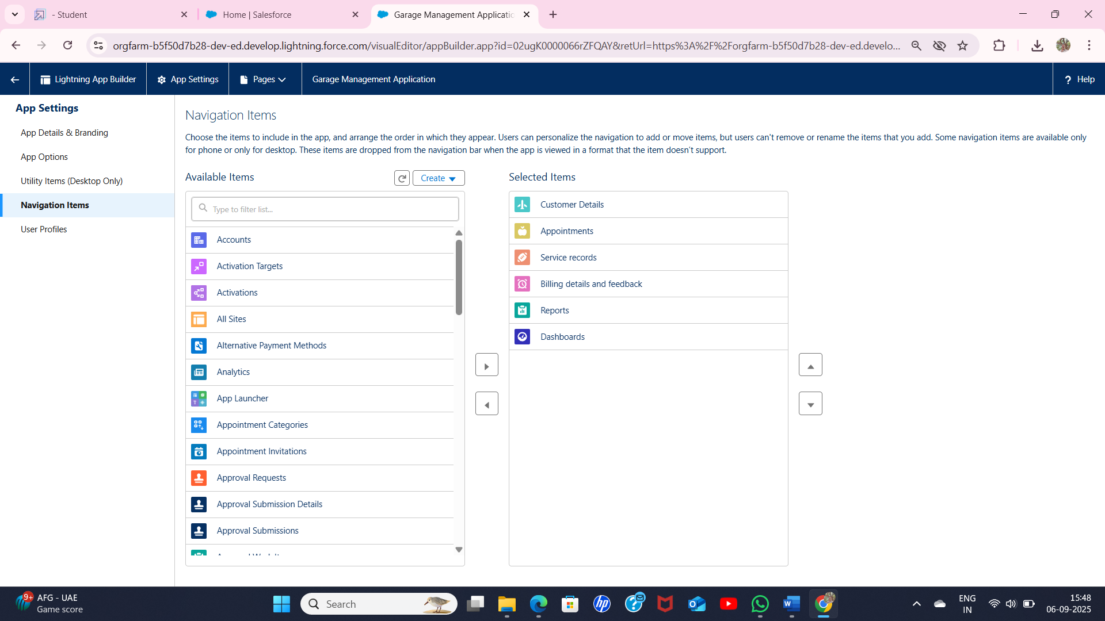

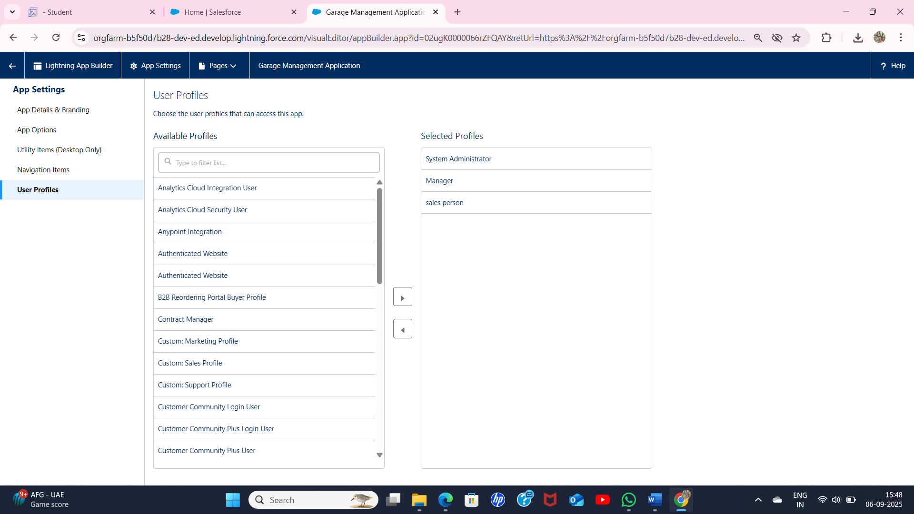

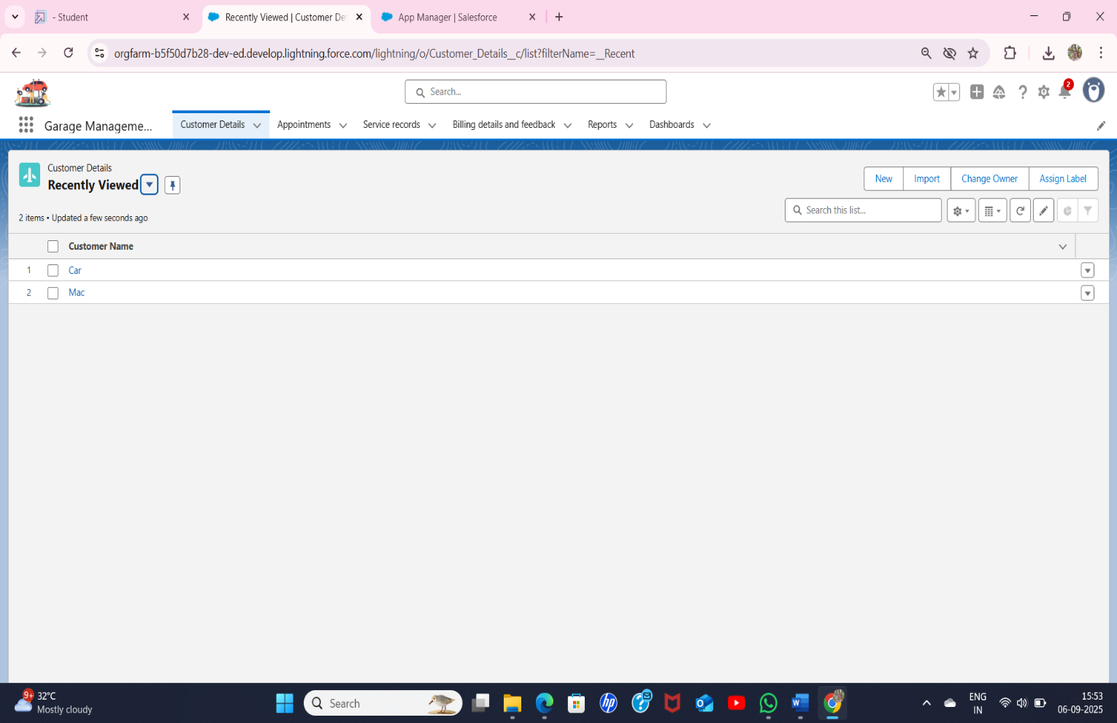

* Custom tabs were created

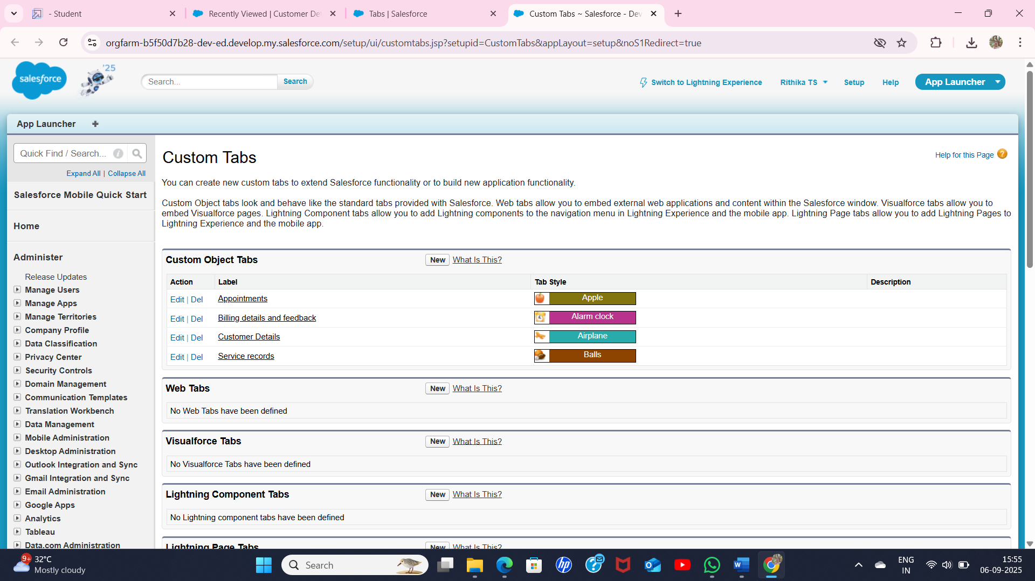

Validation Rule:

To create a validation rule

* to an Appointment object and
* to Billing details and feedback object.

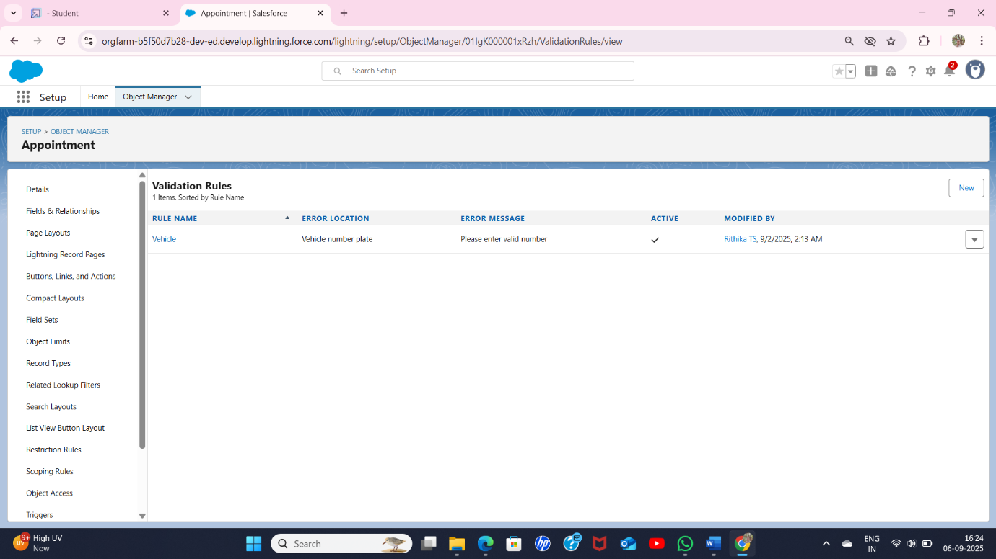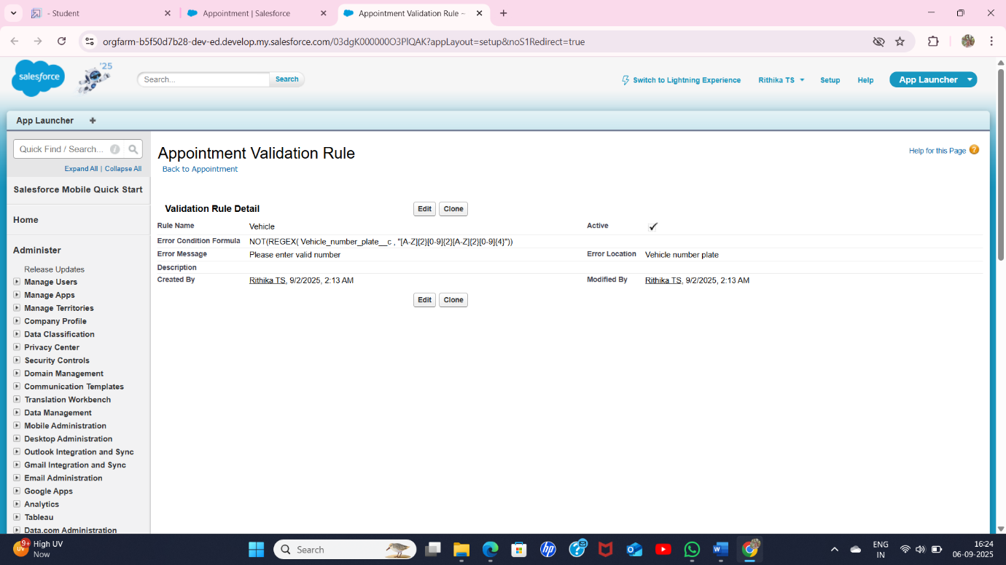

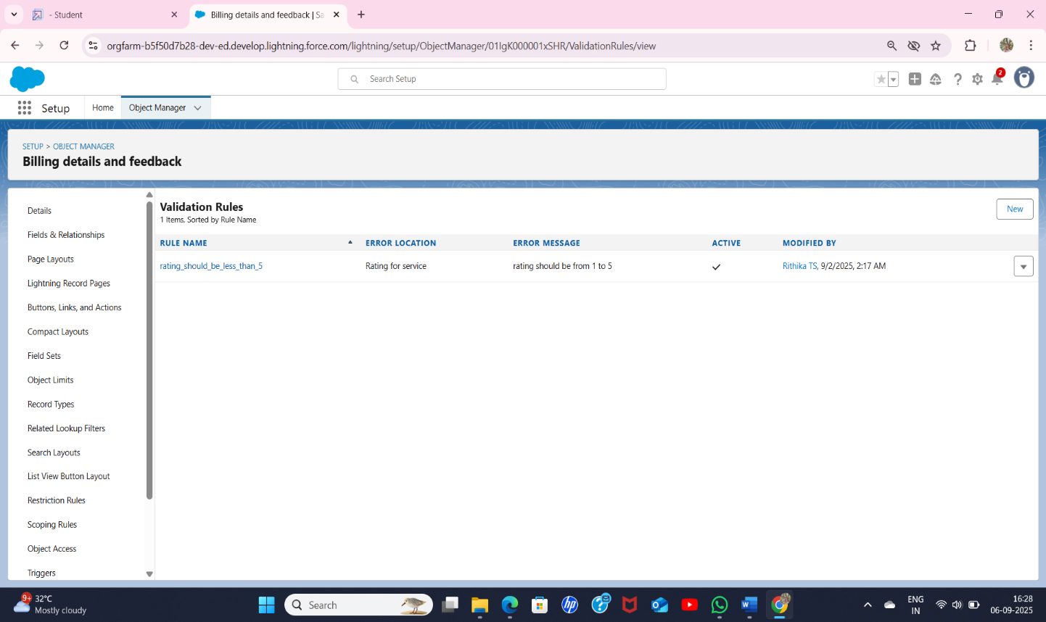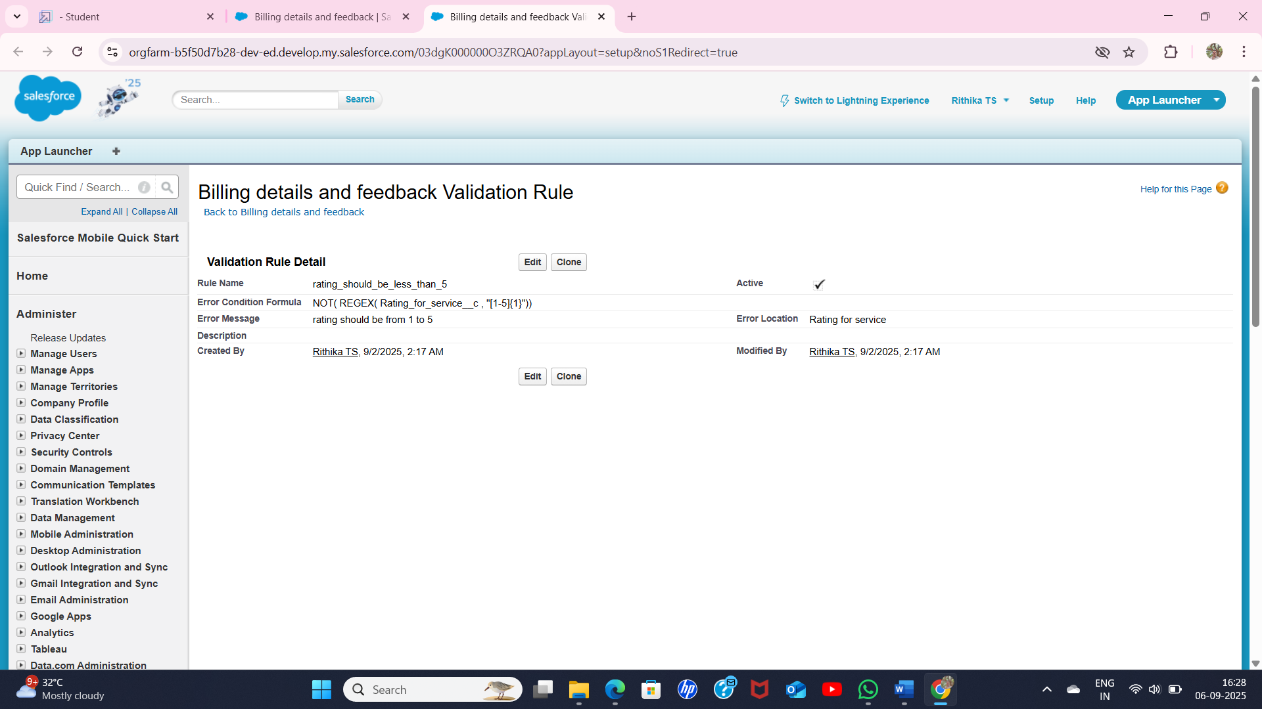

Duplicate Rule:

To create a matching rule to an customer details objects

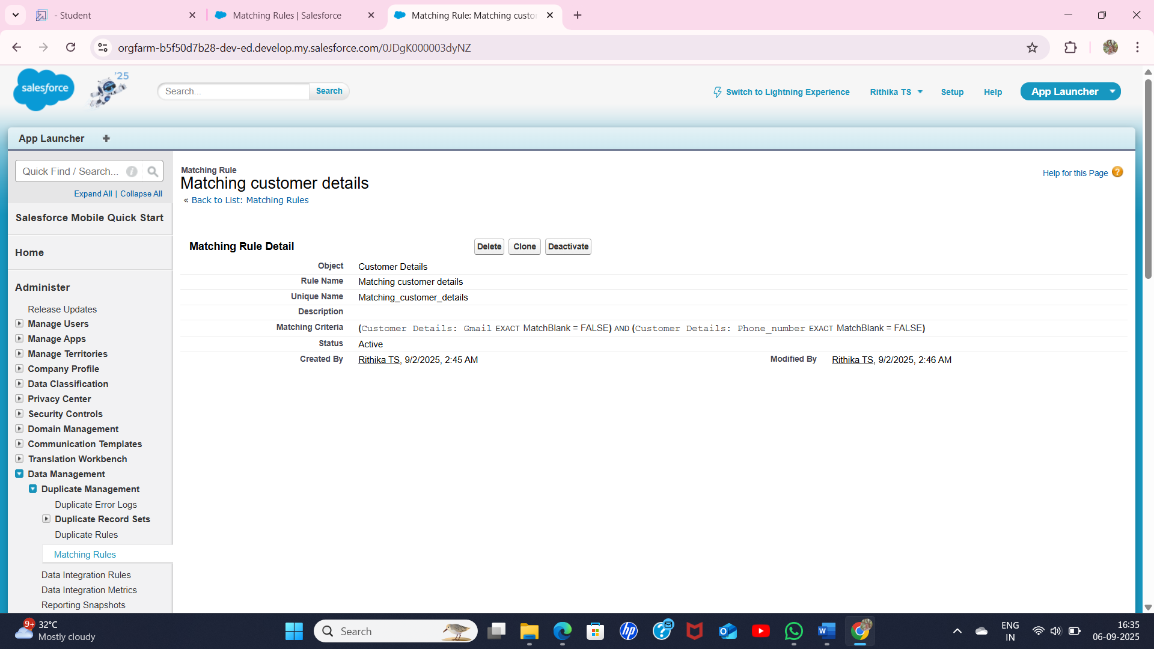

To create a duplicate rule to an customer details objects

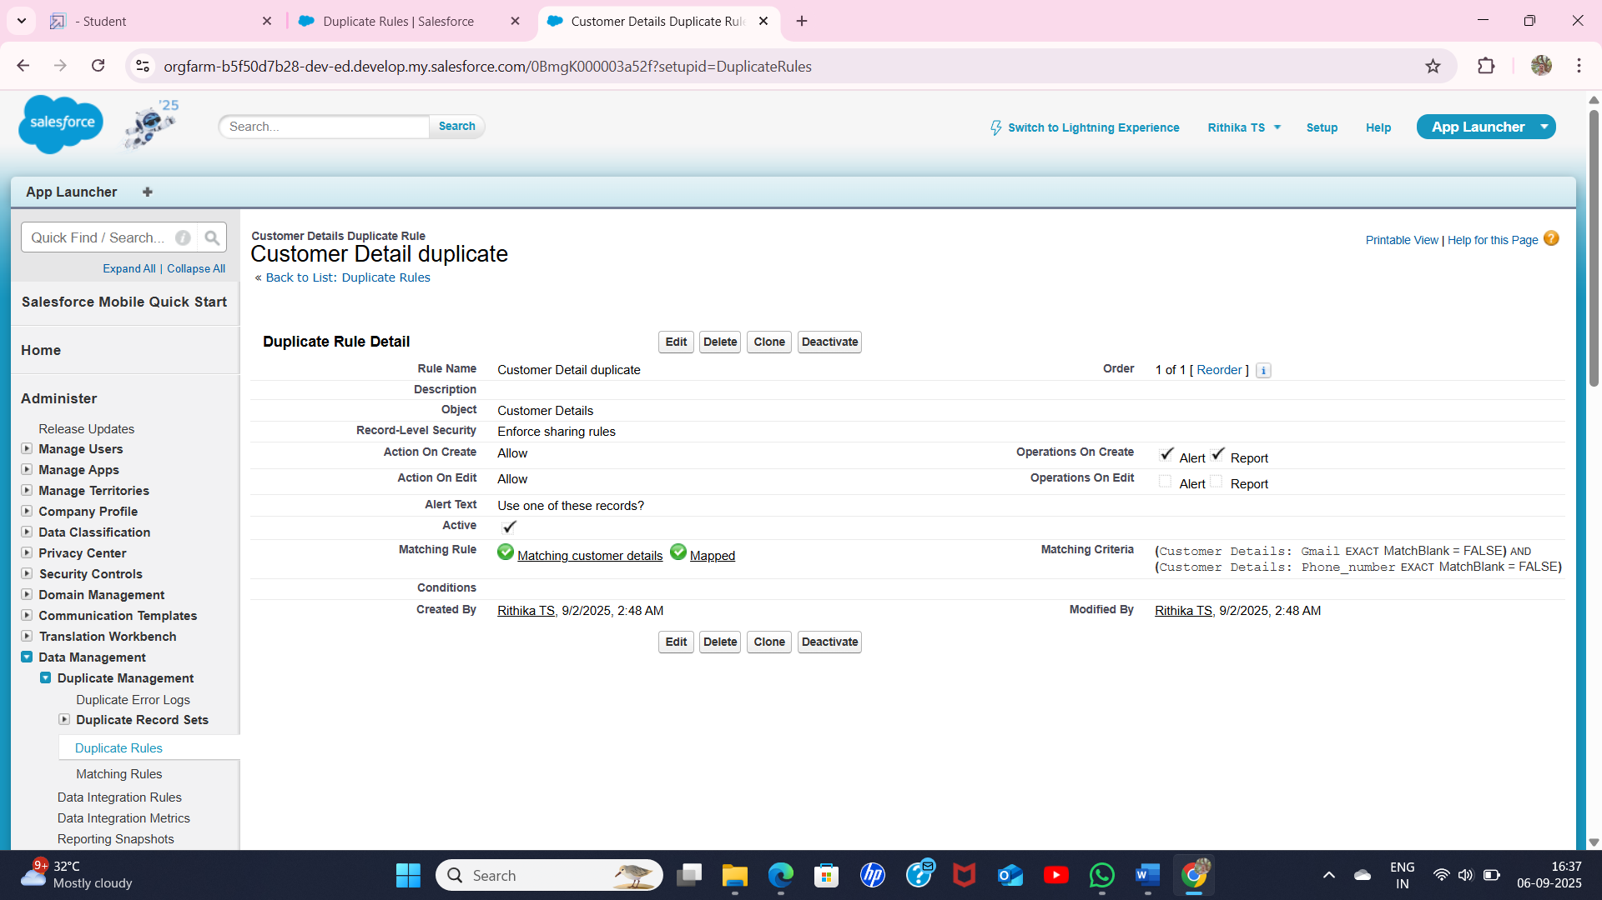

Profile:

To create profile for Manager: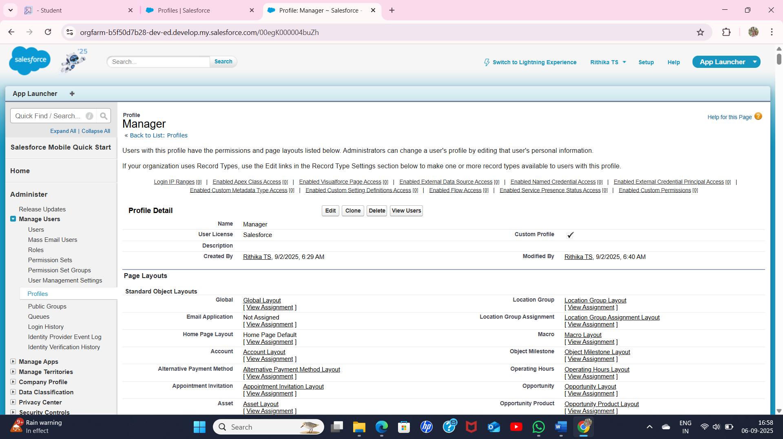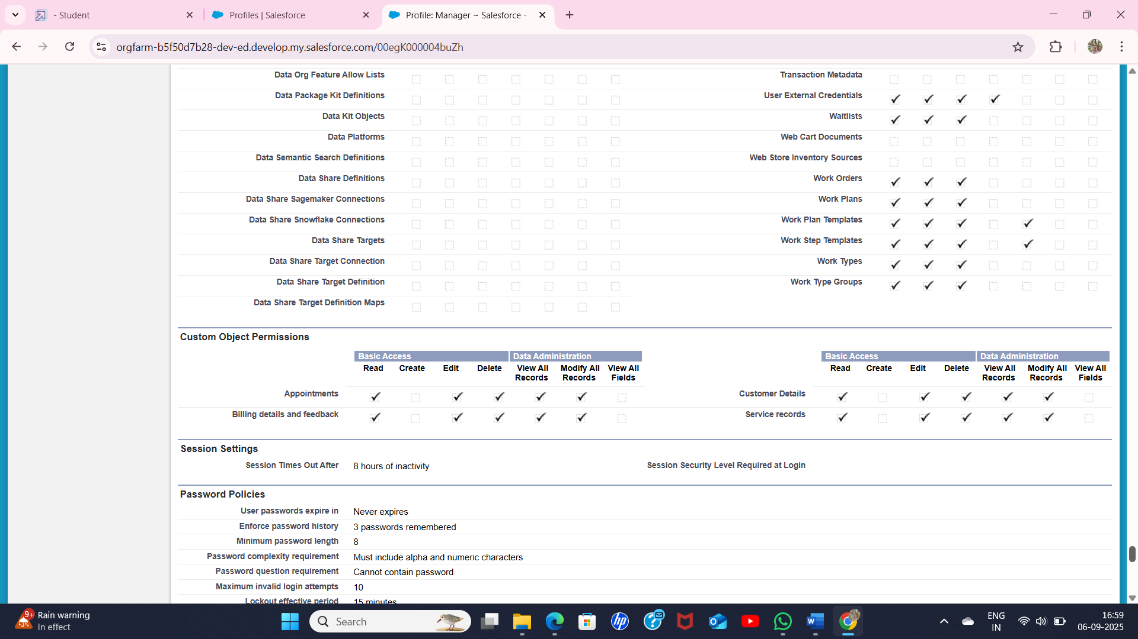

To create profile for Sales person:

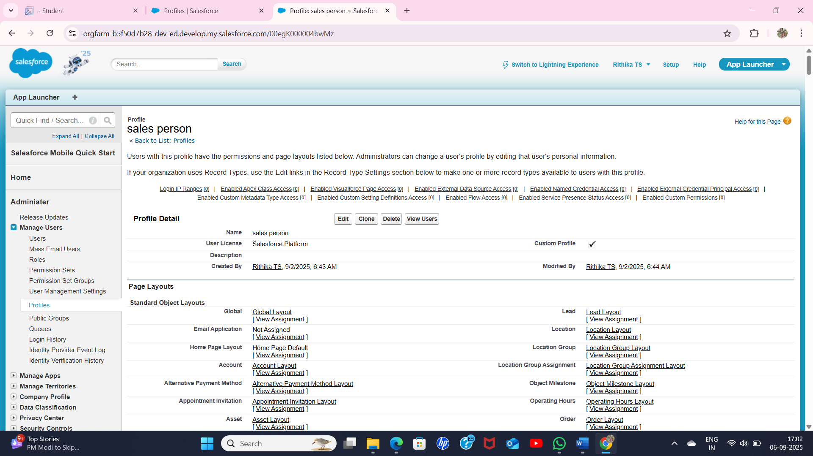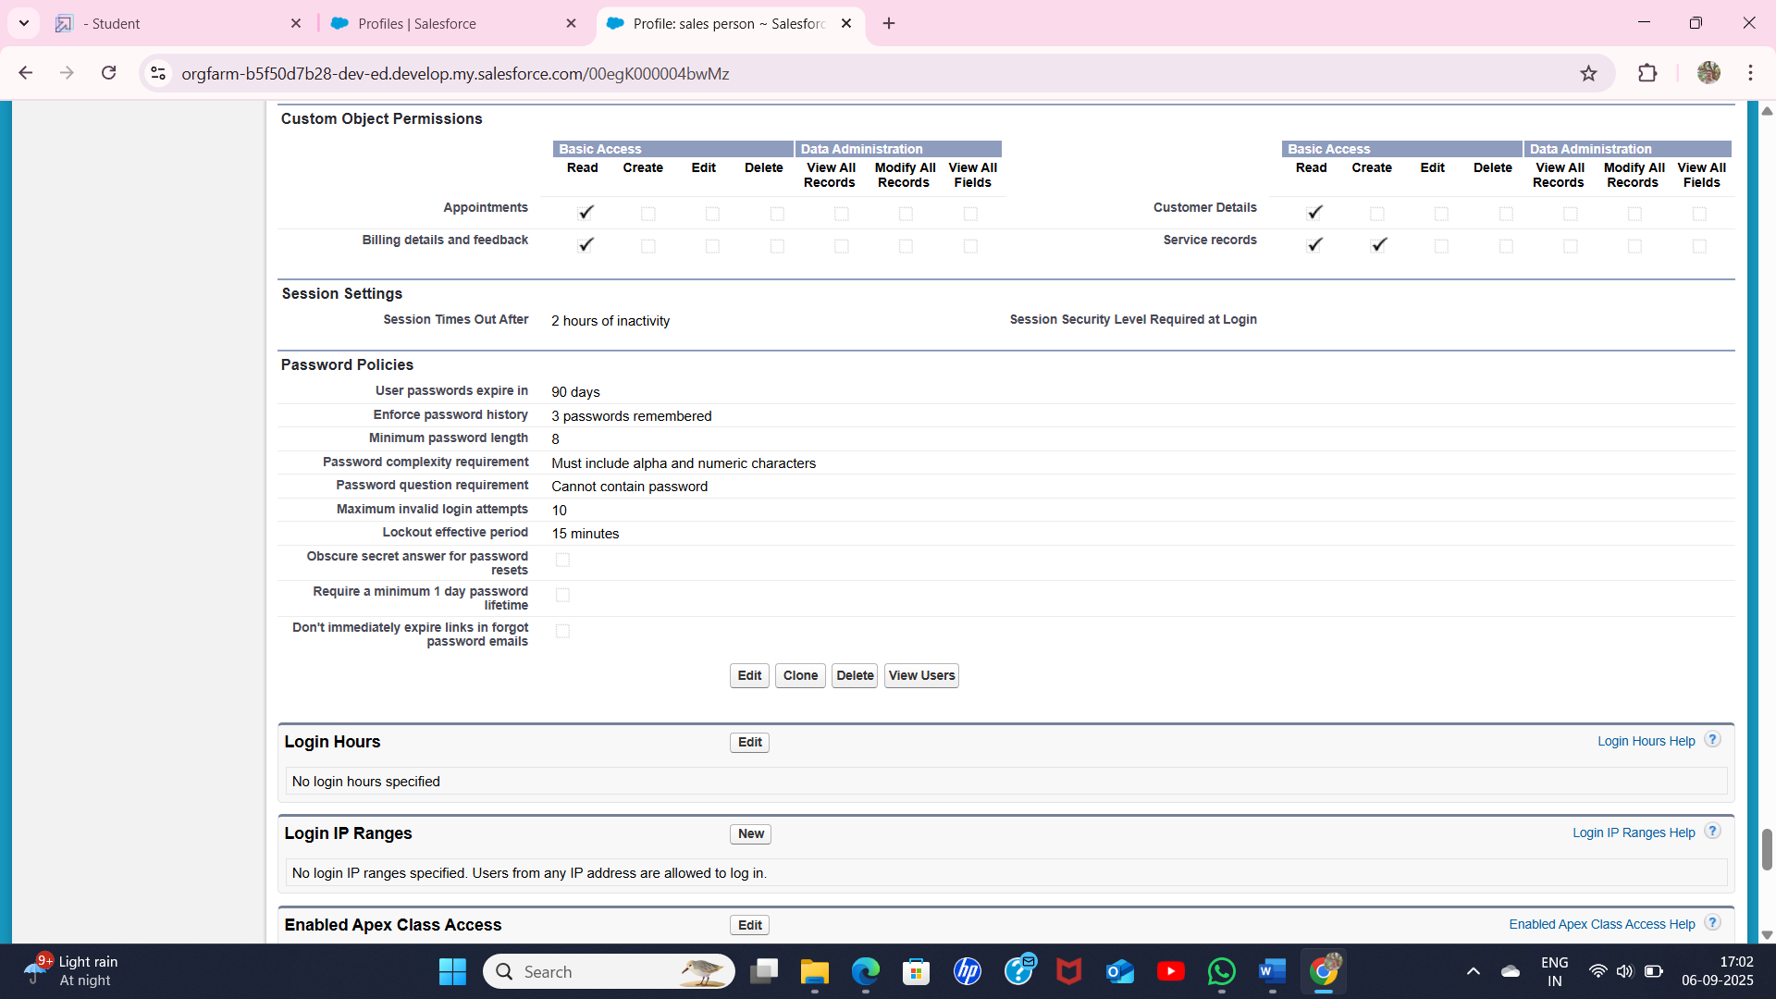

* Roles were assigned to manager and others

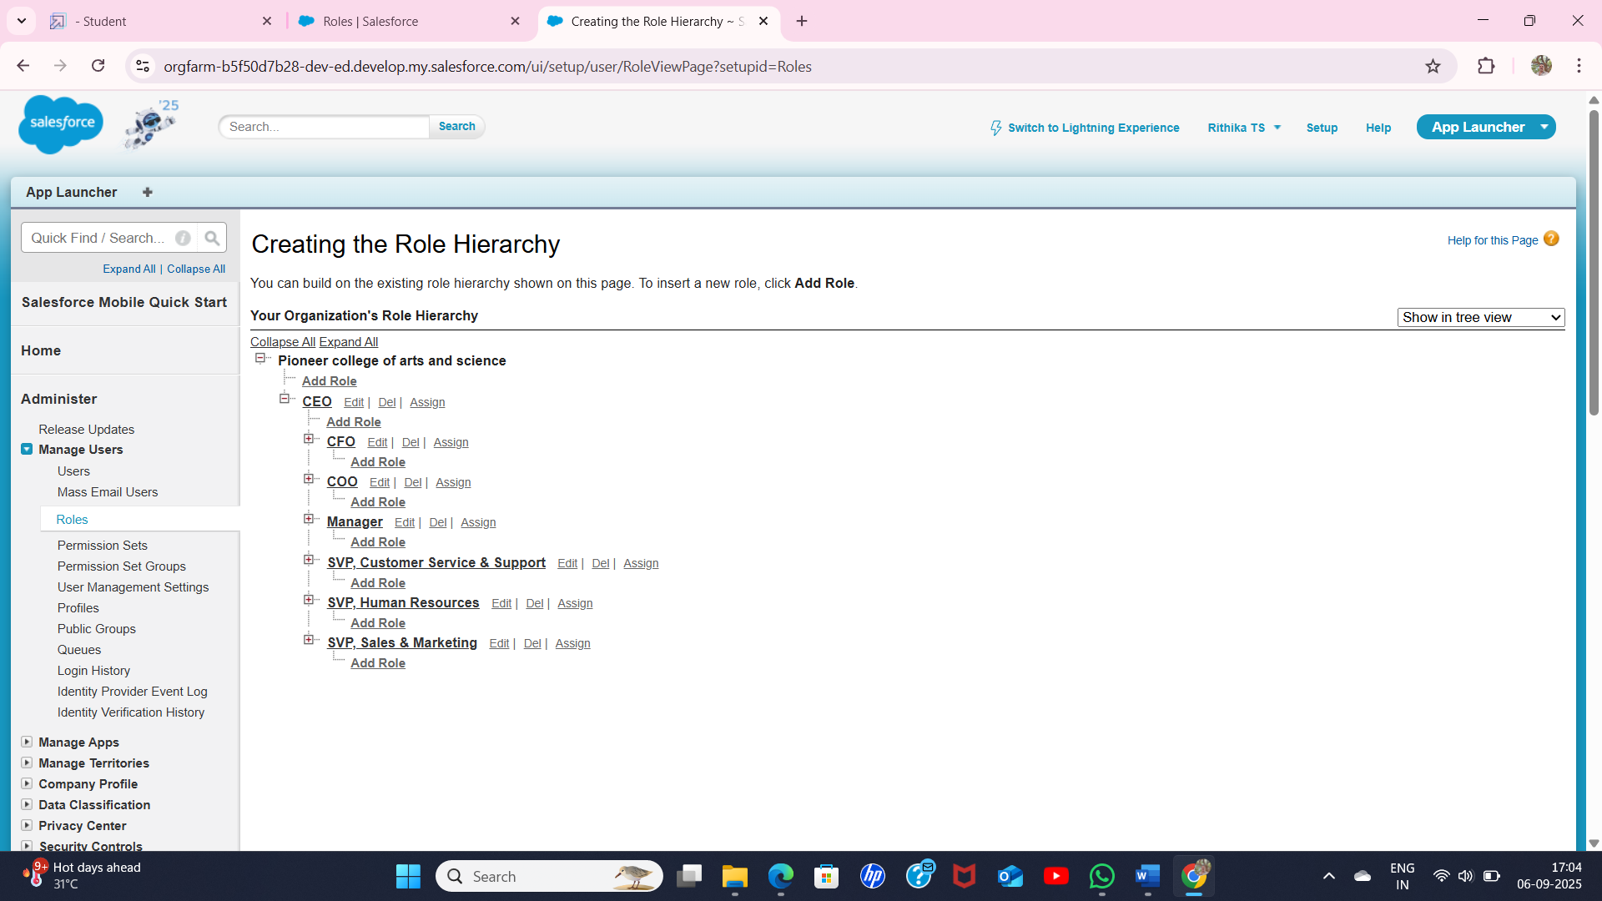

Users:

Users were created with roles assigned as manager , sales person in salesforce platform.

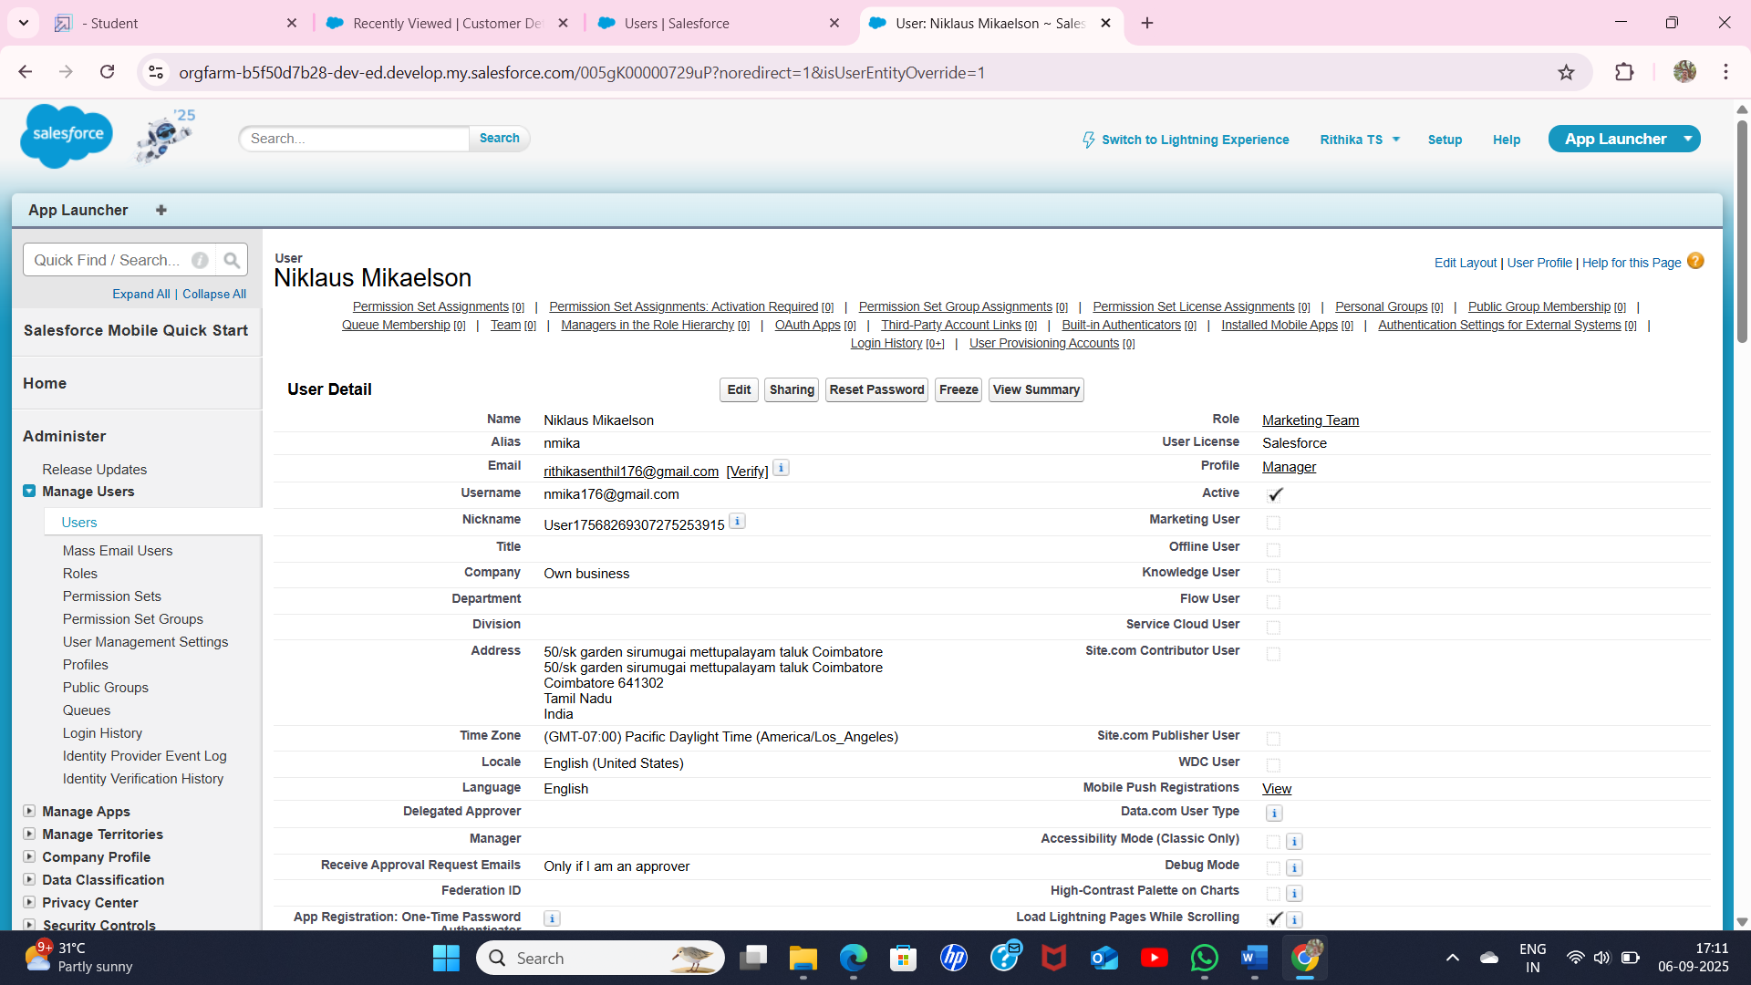

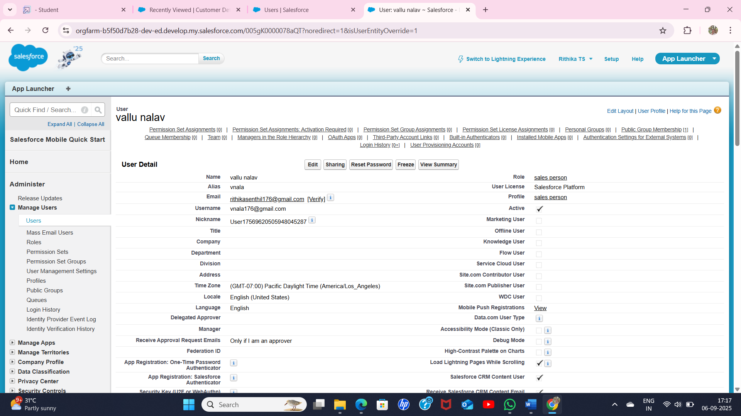

To create a public group: 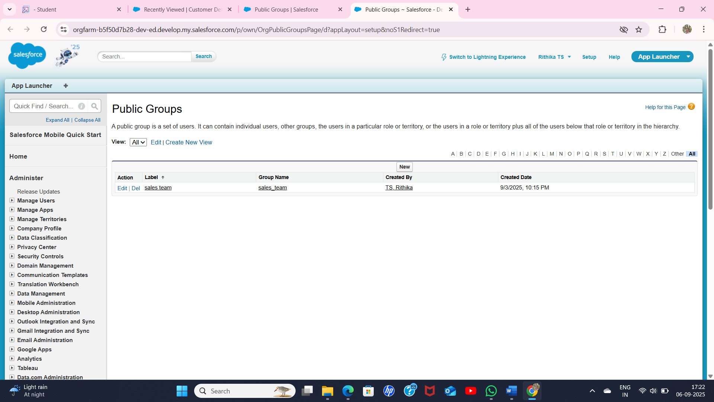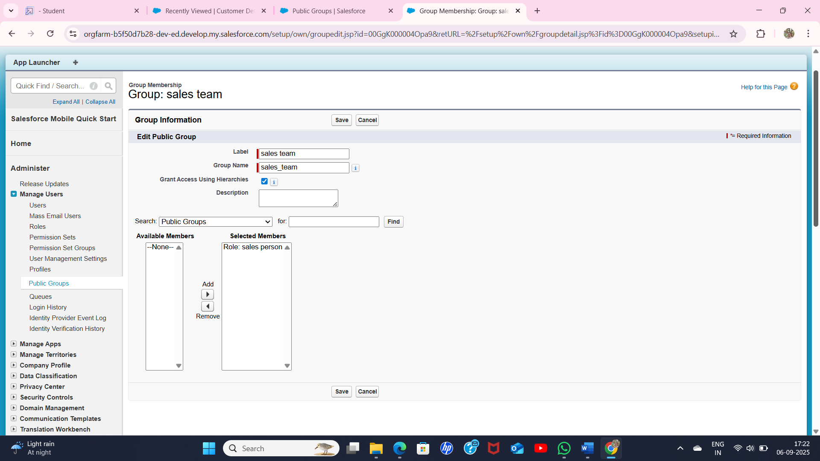

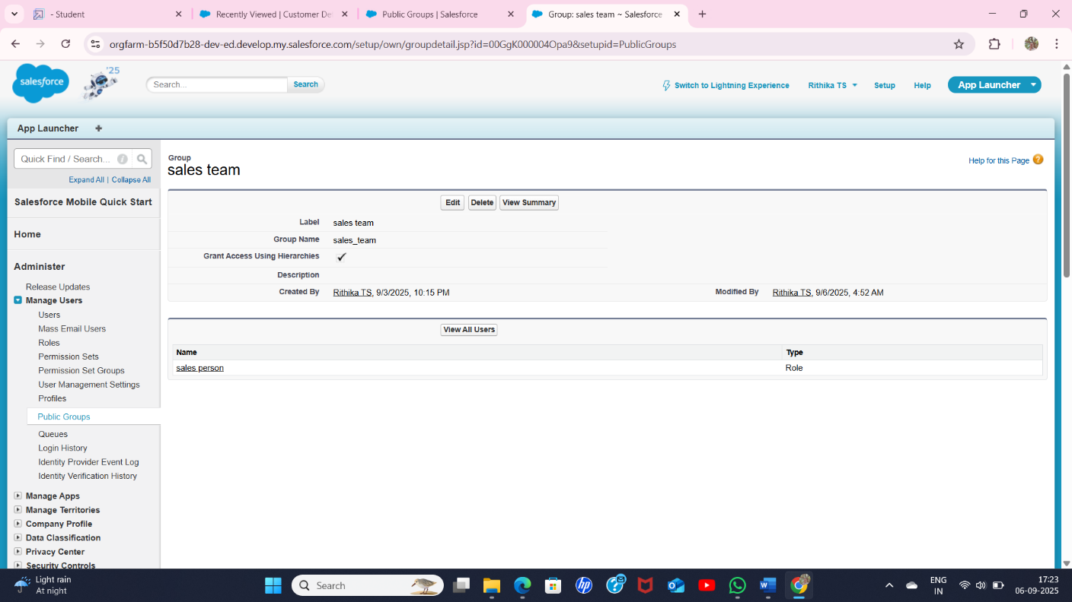

To create a  Sharing setting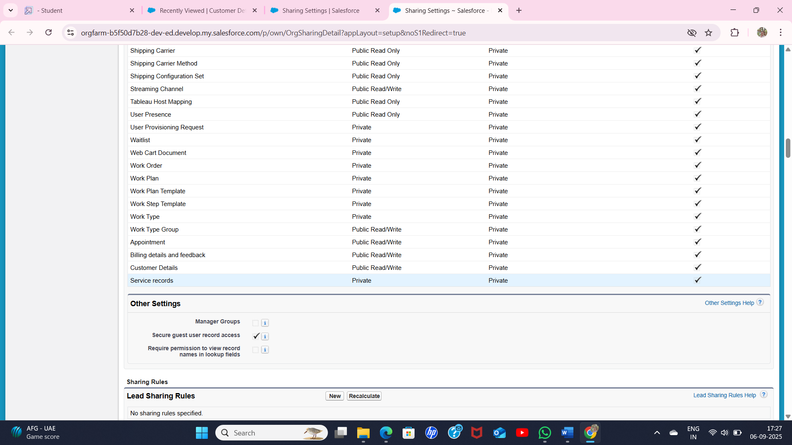

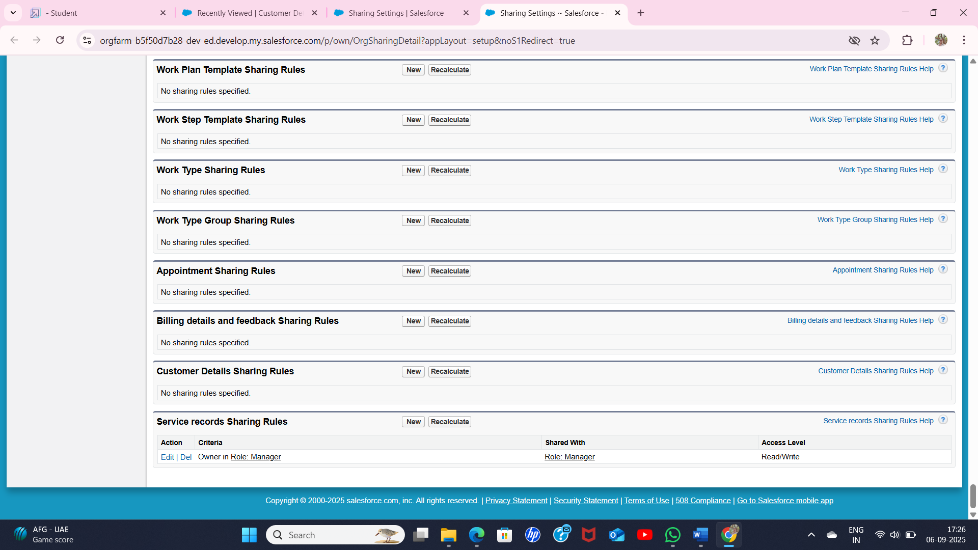

To create a flows: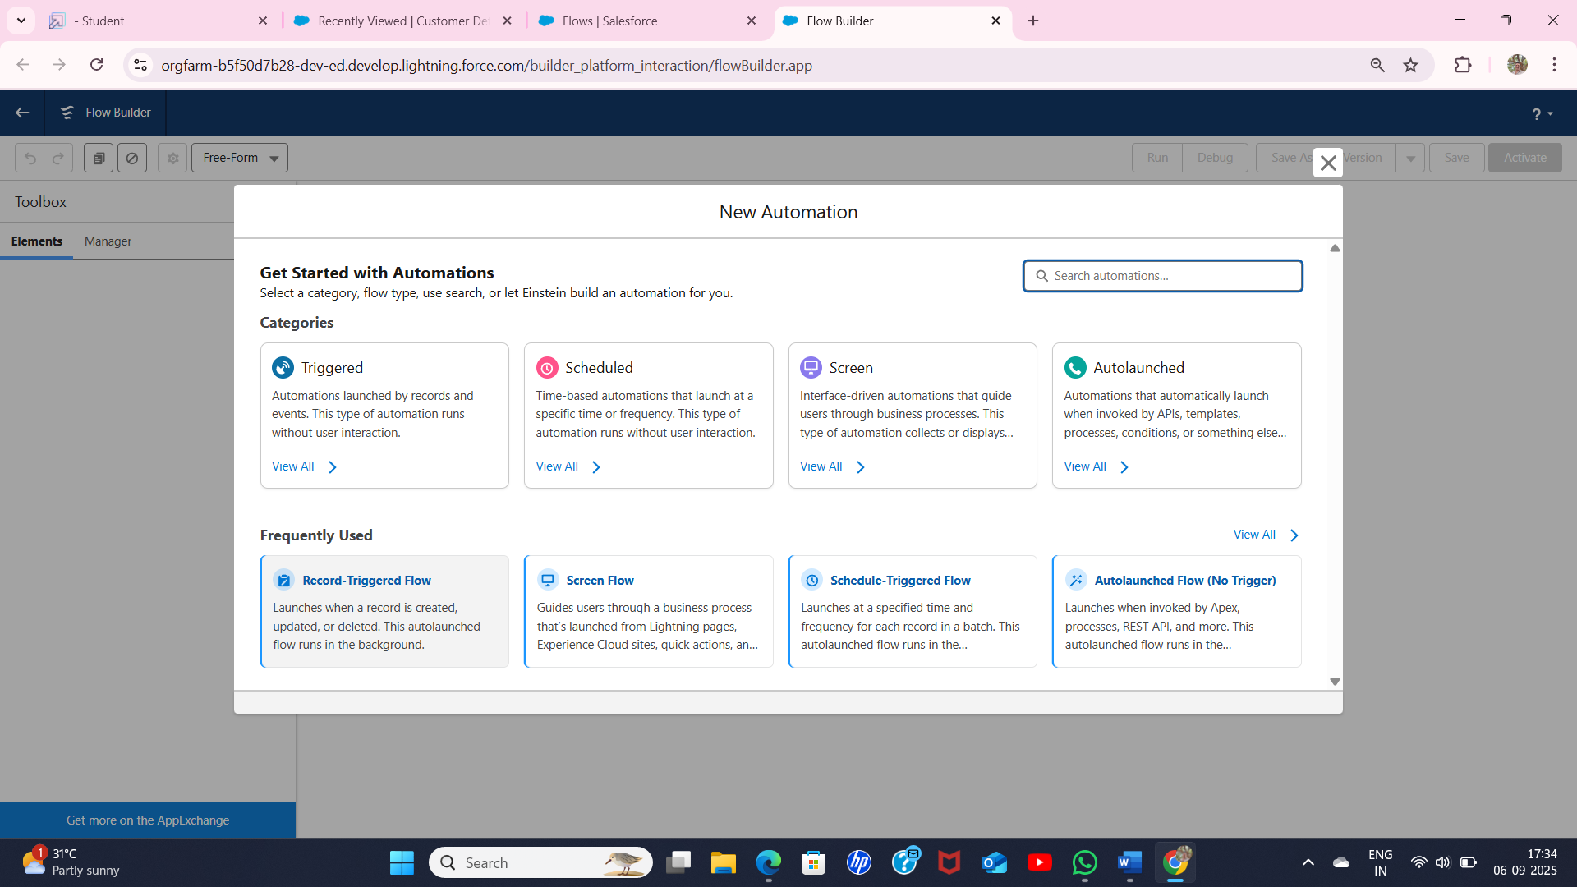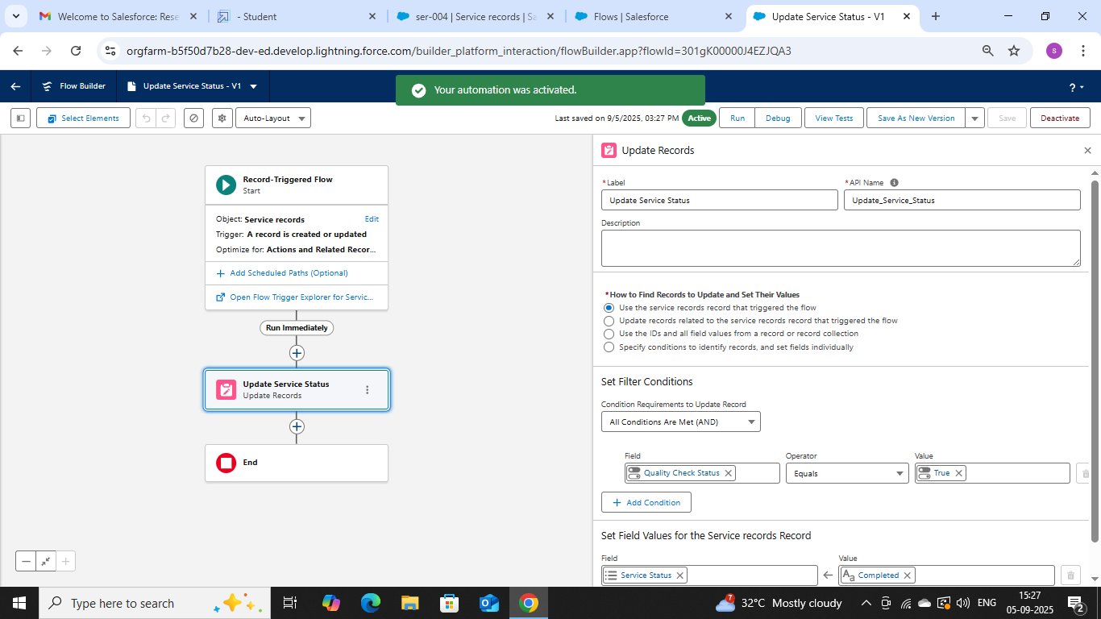

Apex Tigger (class) is created as AmountDistributionHandler

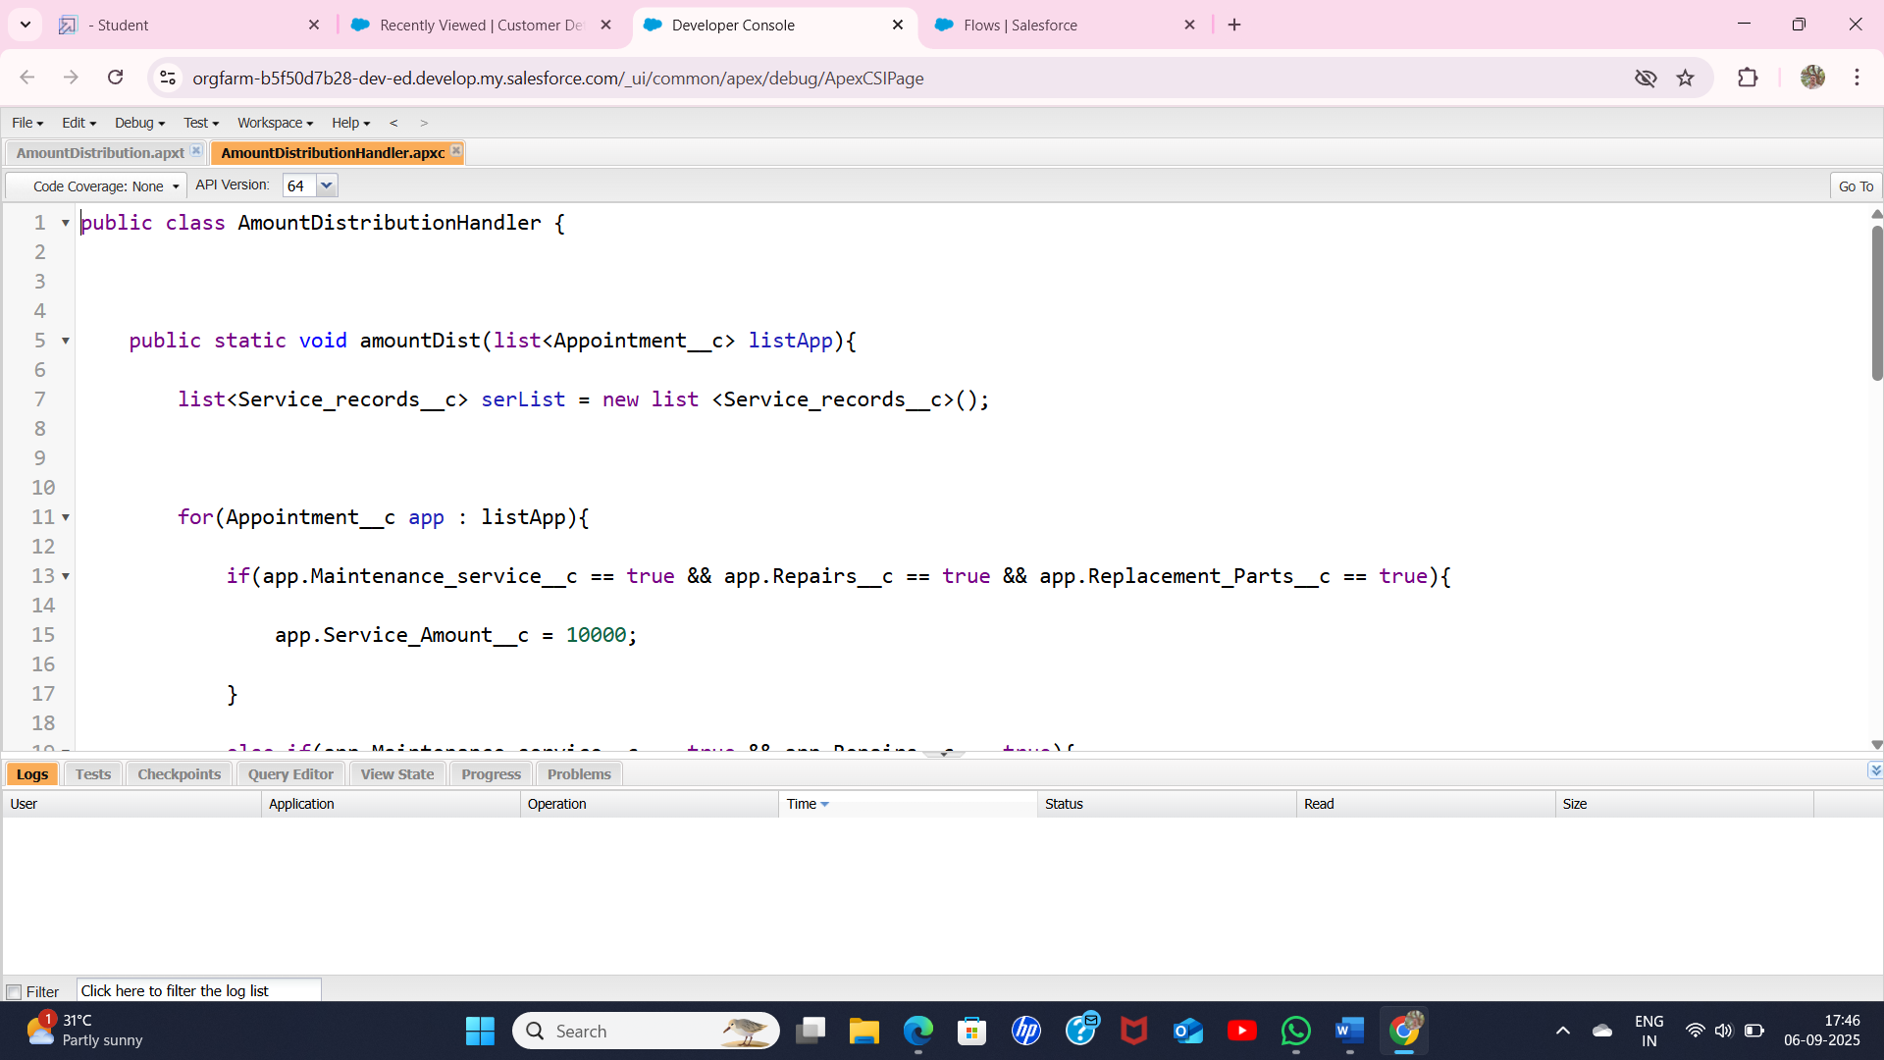

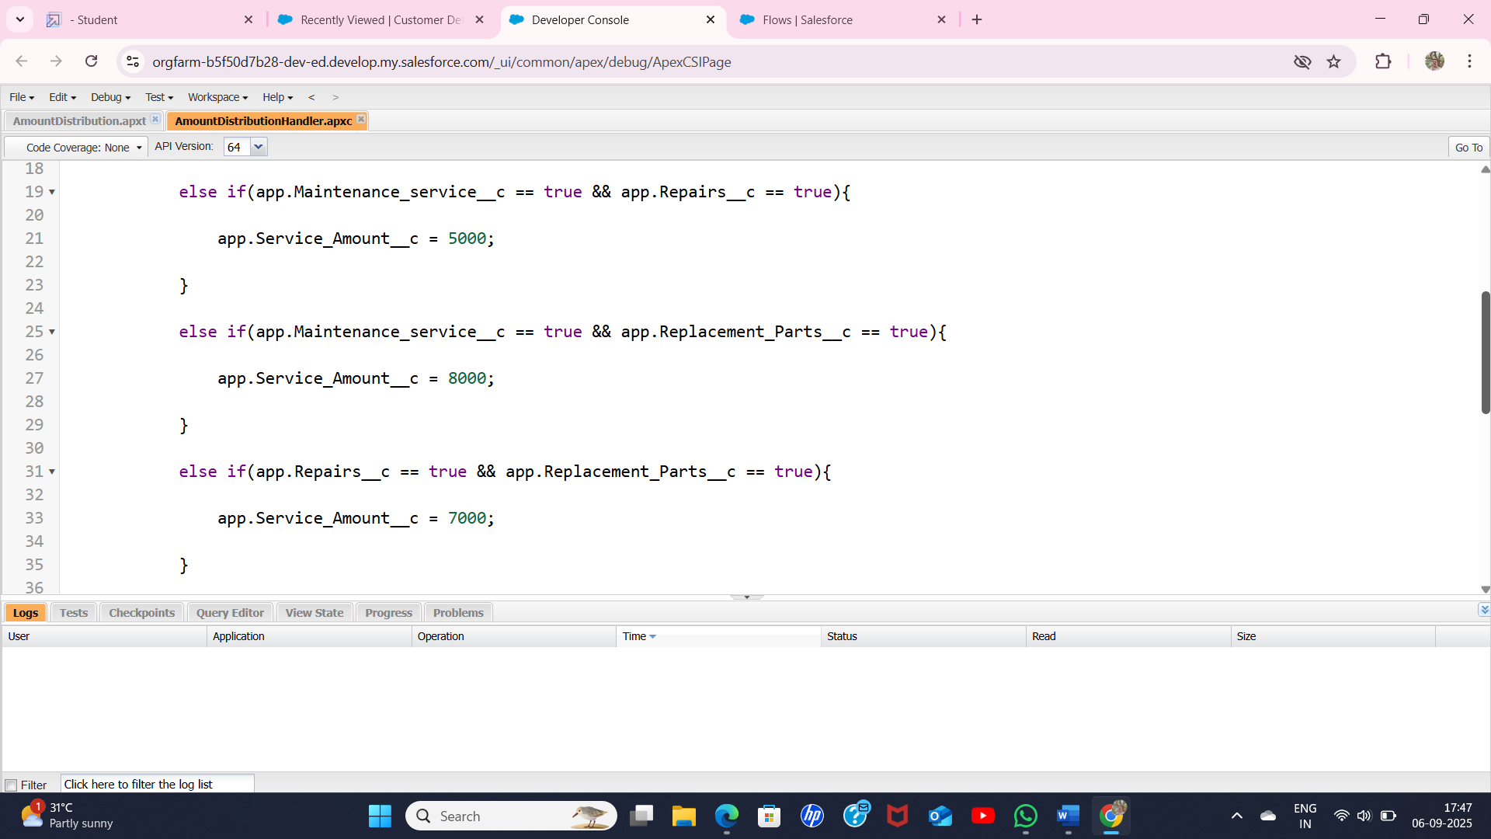

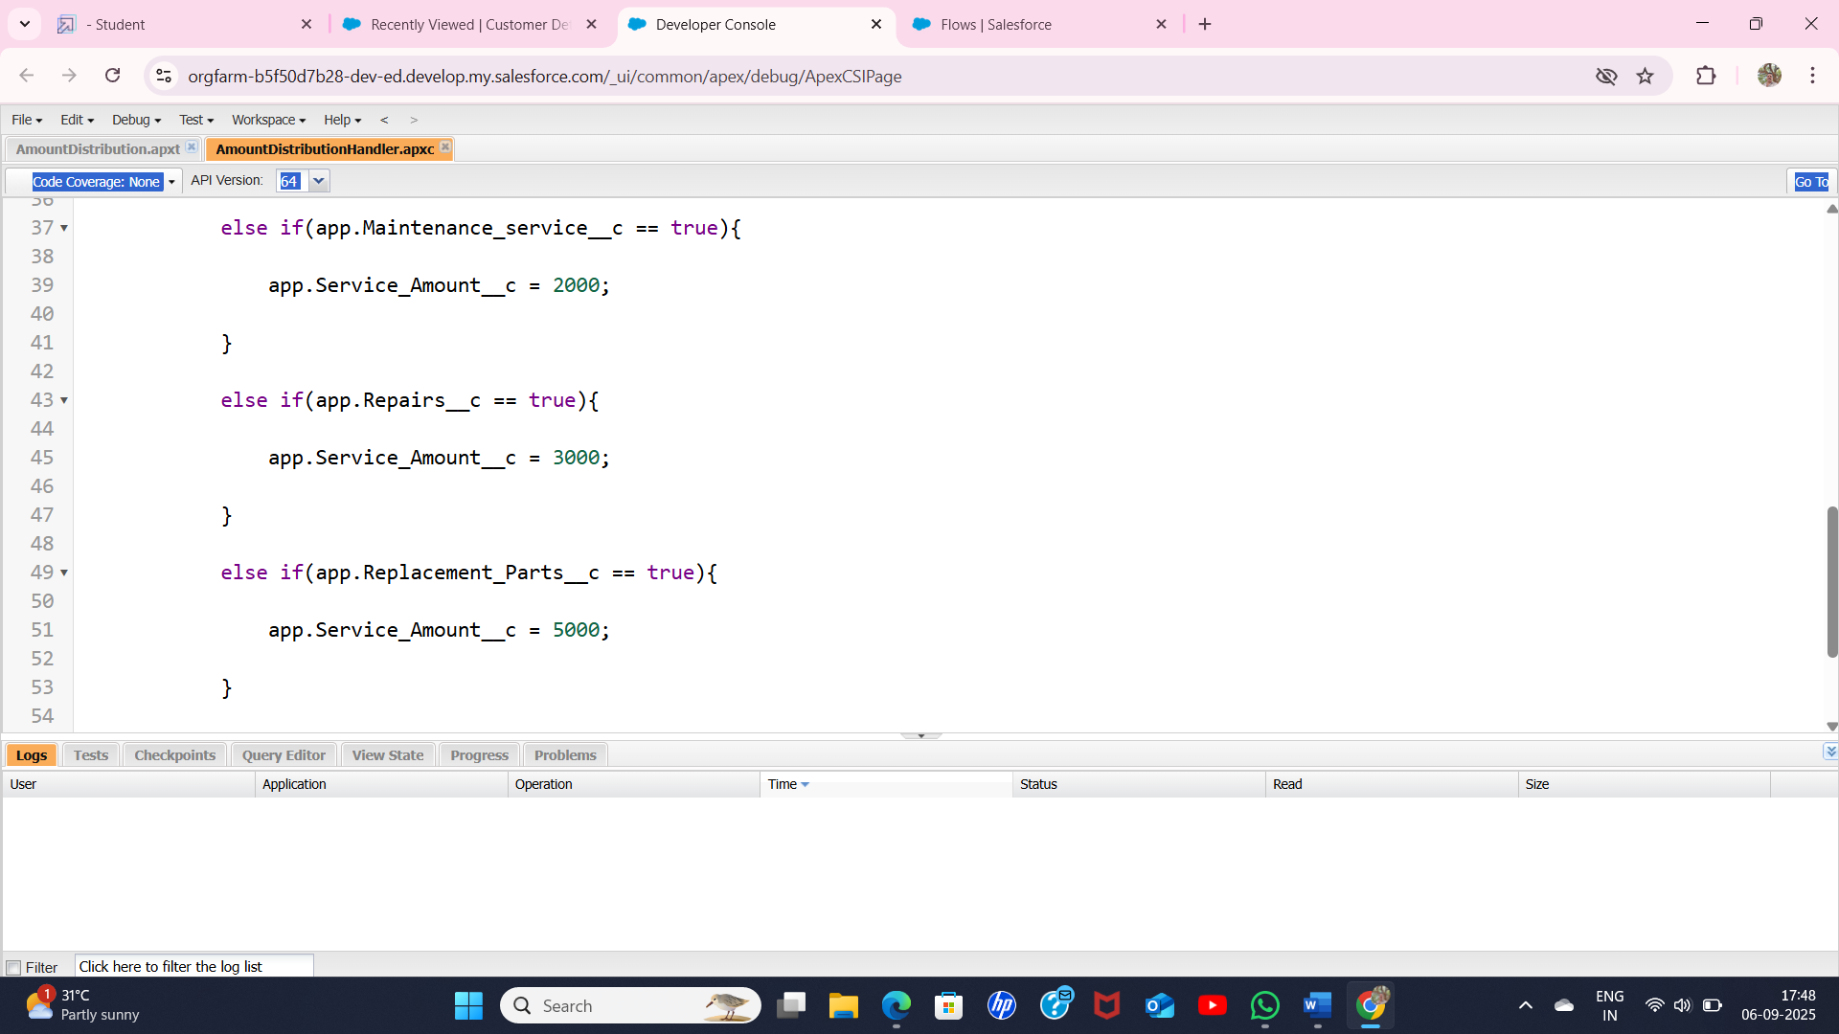

Next , apex tigger was created as AmountDistribution

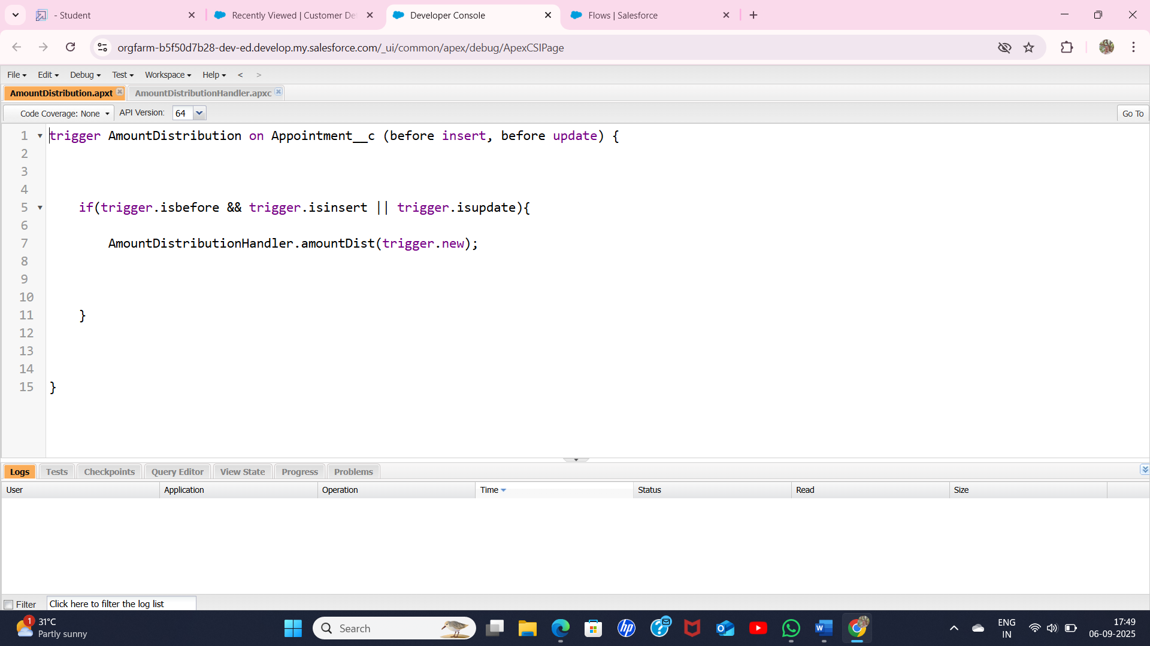

Reports were created

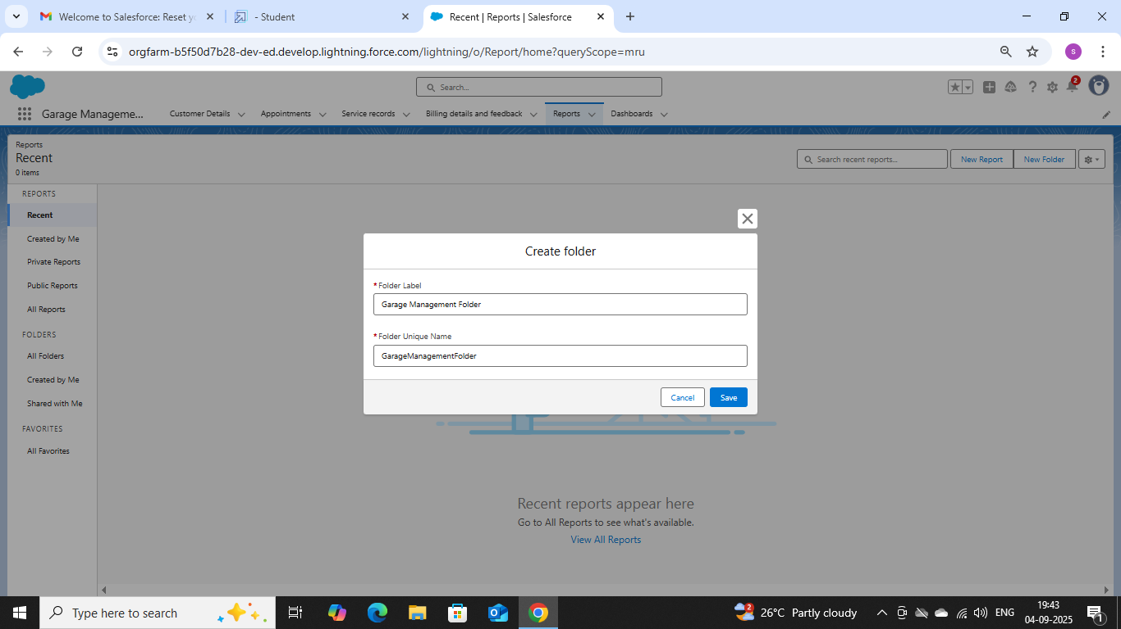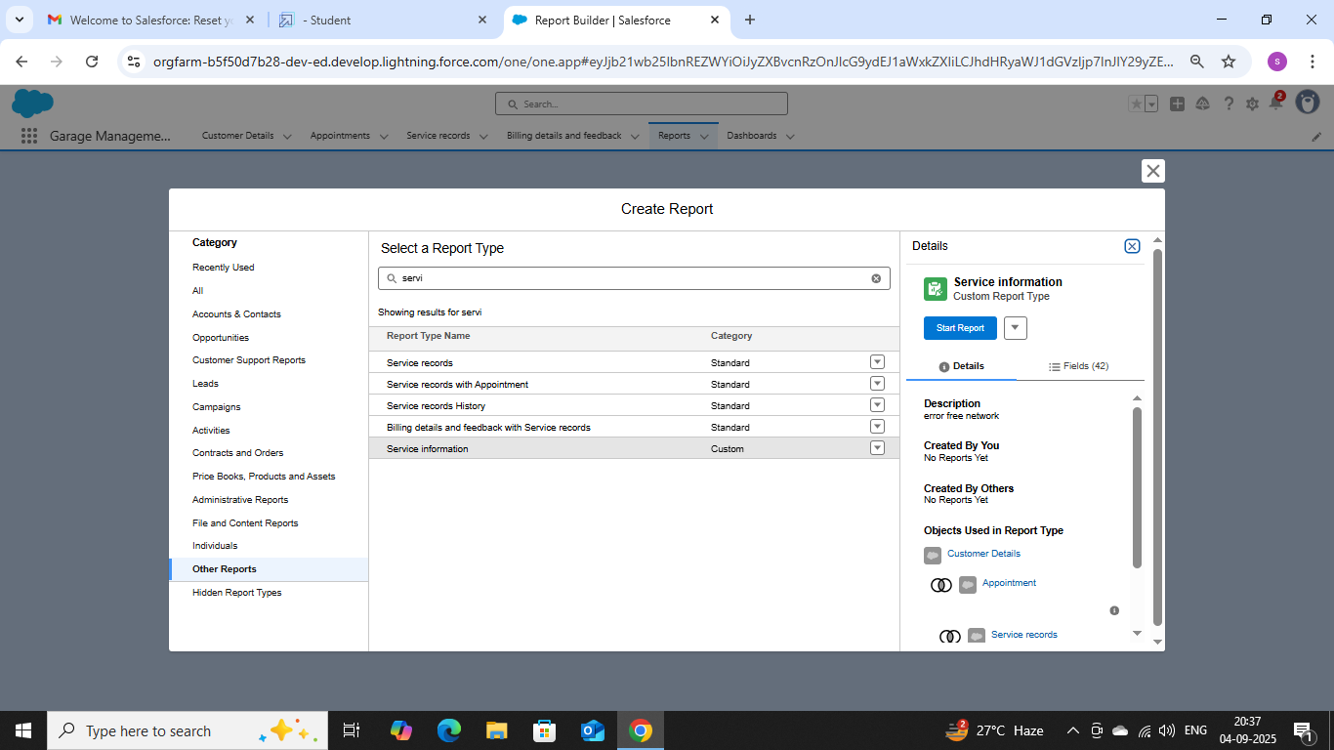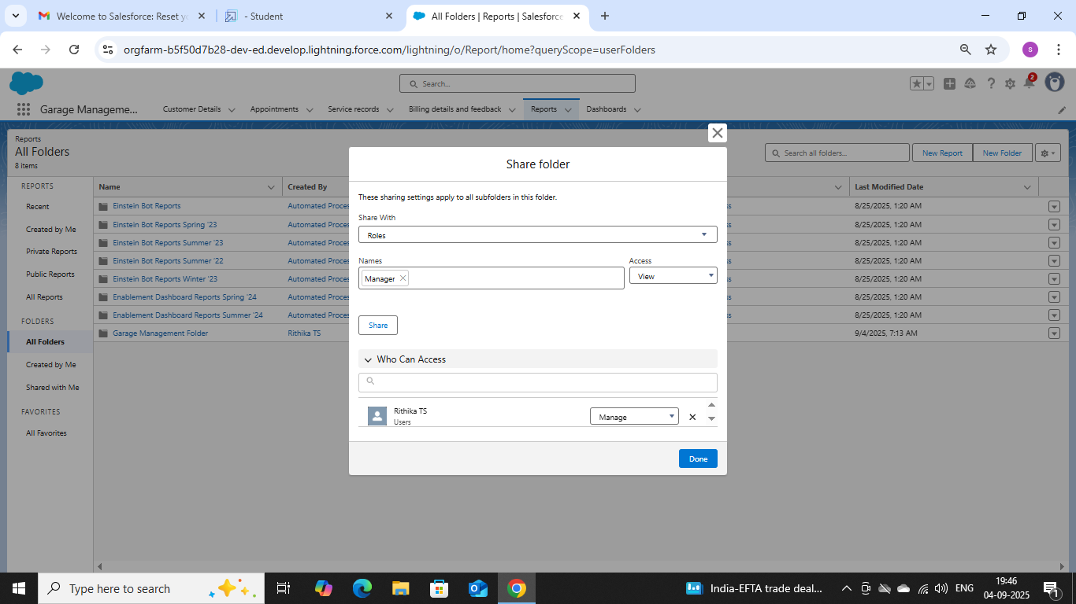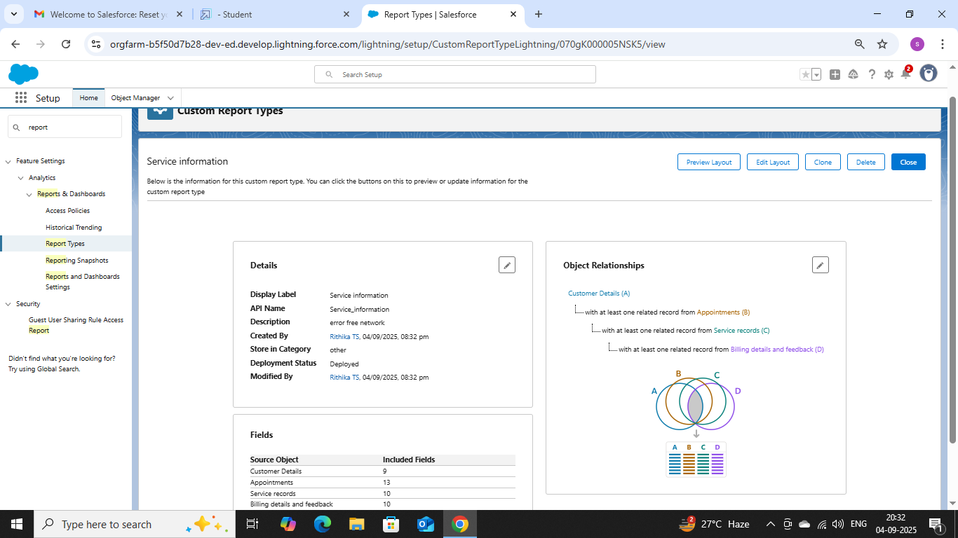

Dashboards were created: 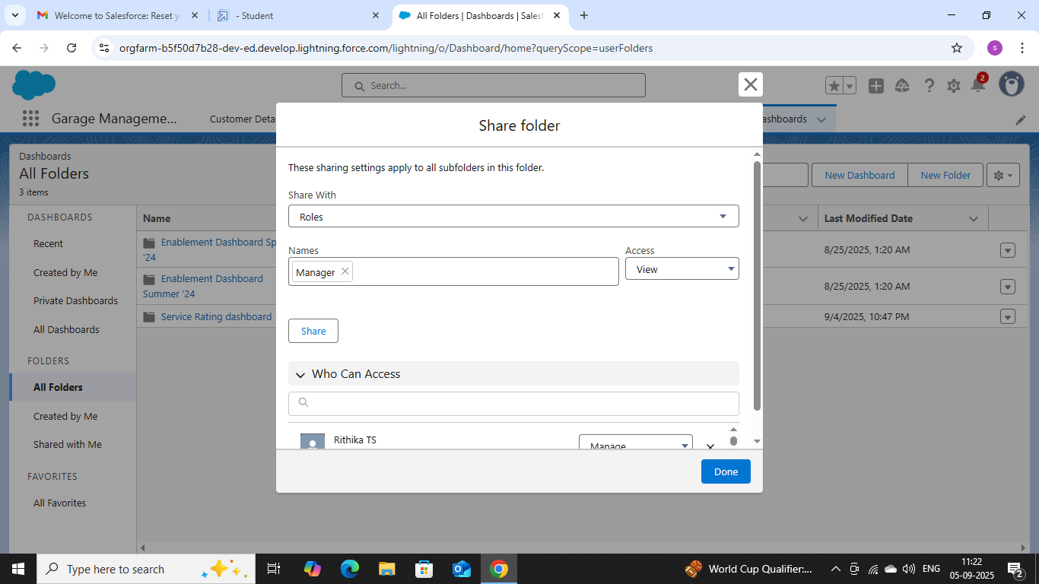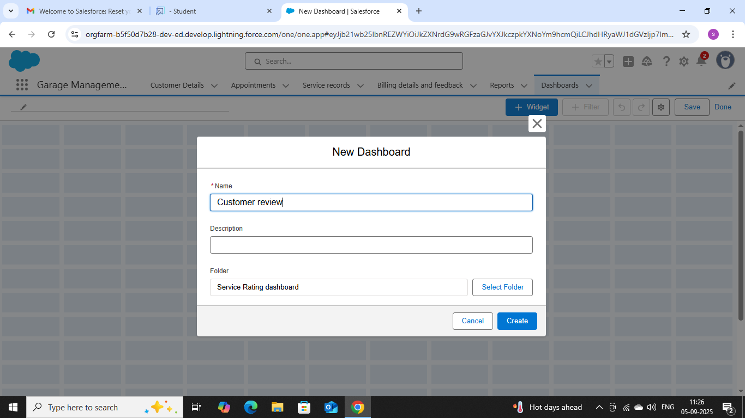

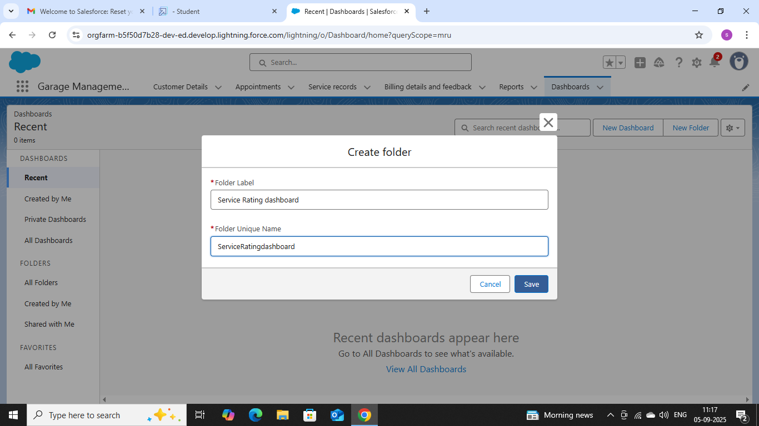

To create a record for user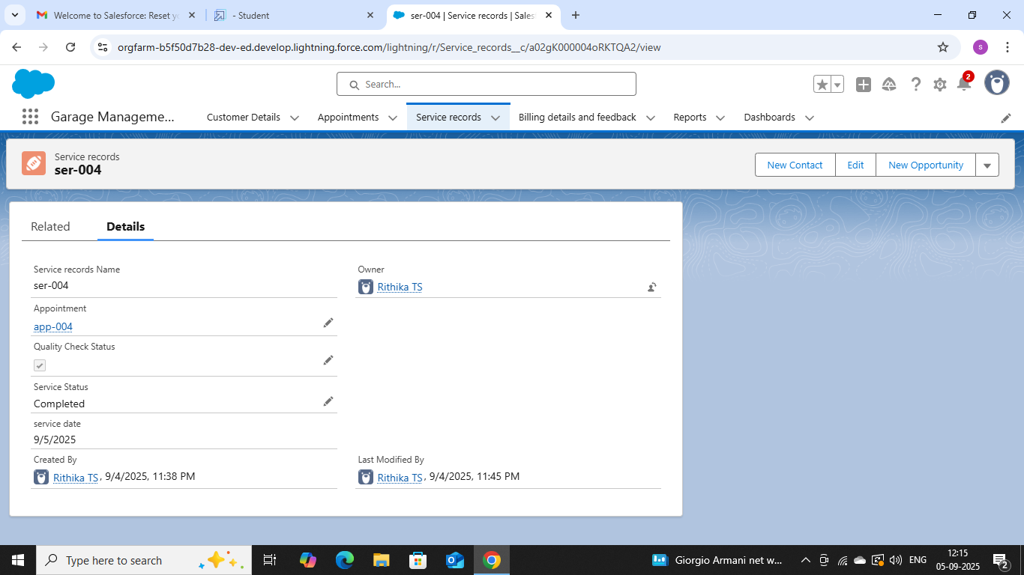

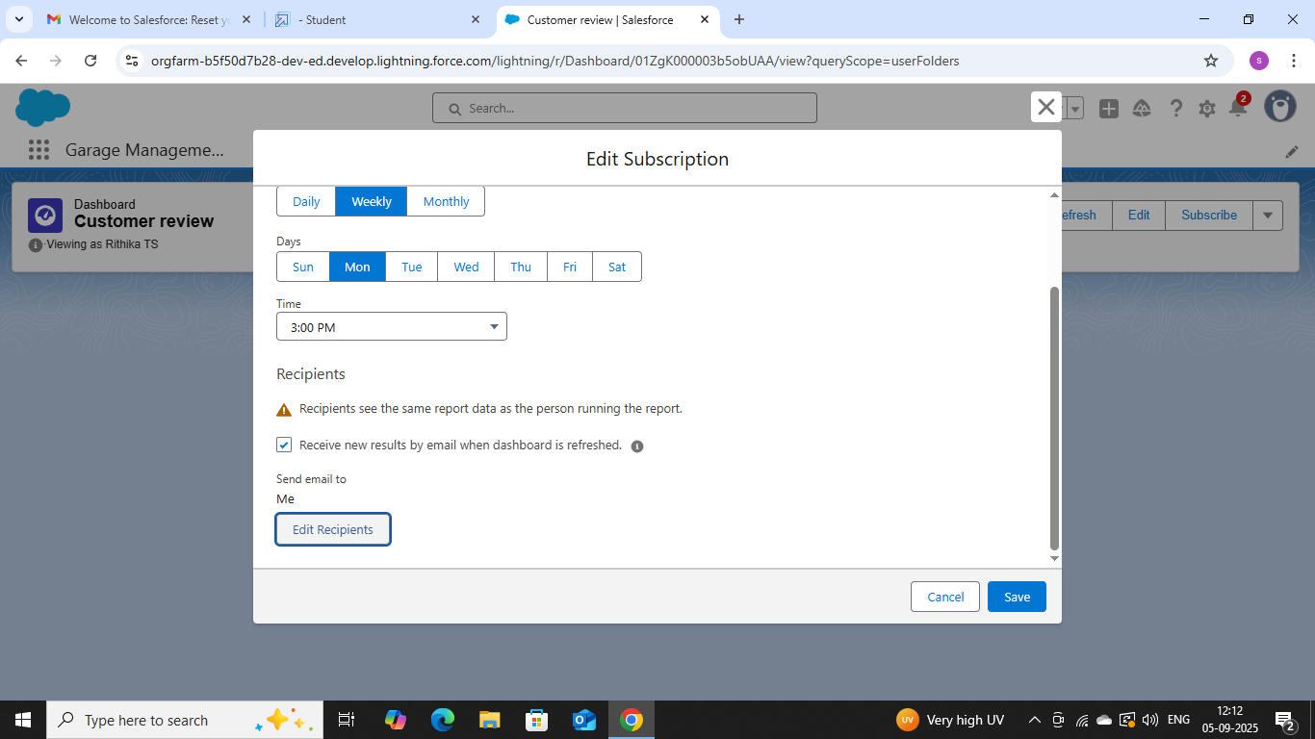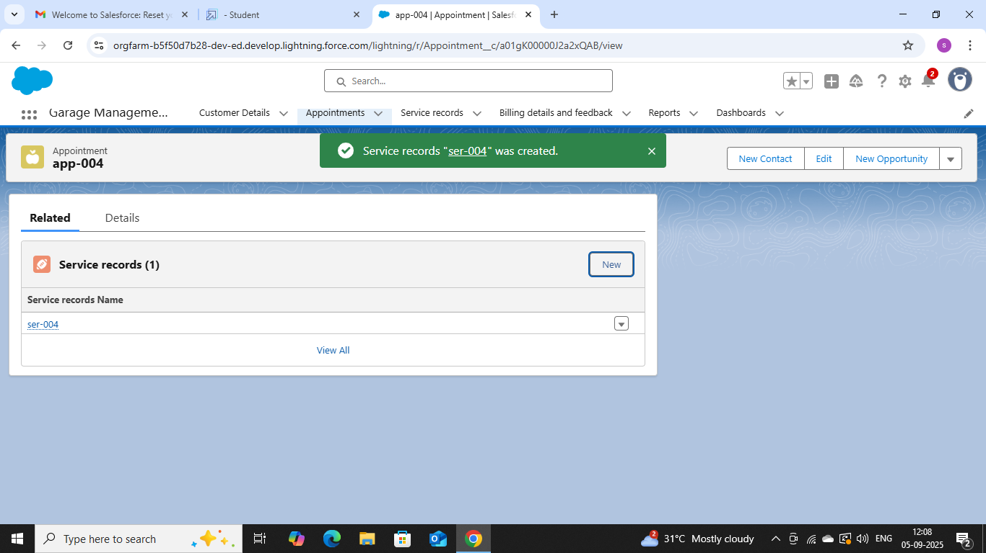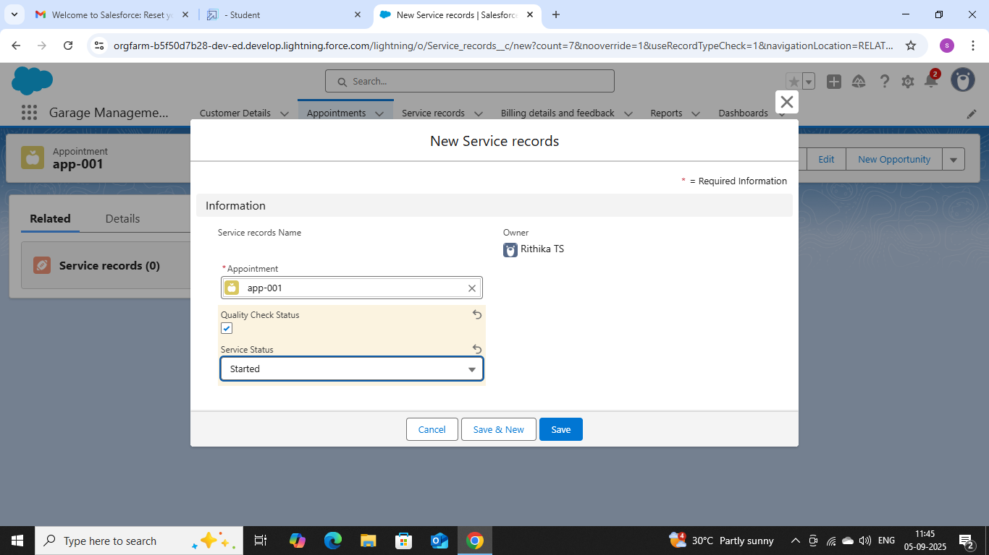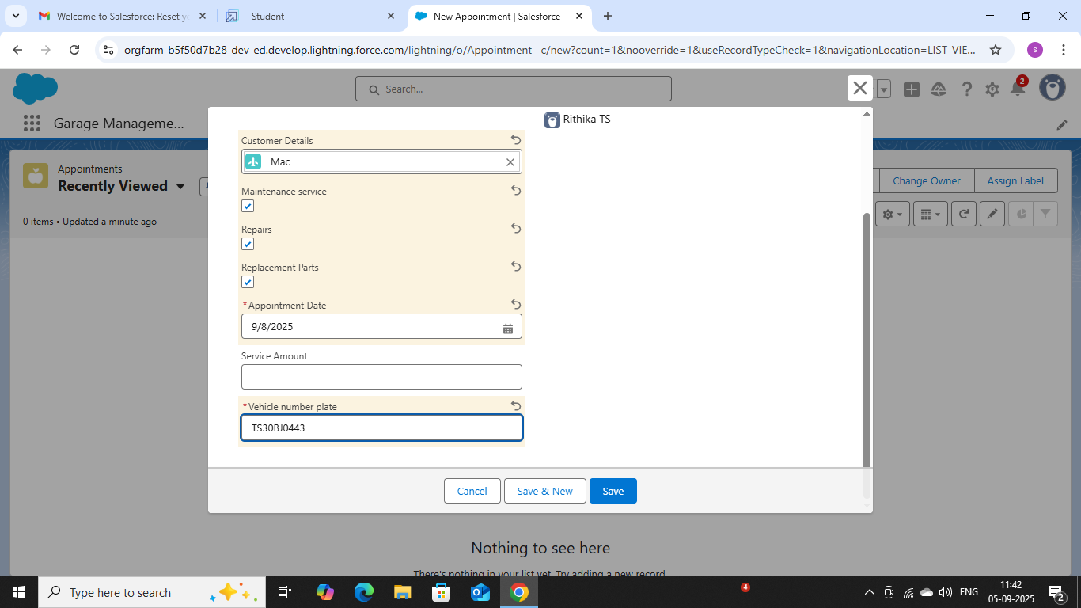

Apex Tigger code:

public class AmountDistributionHandler {

    public static void amountDist(list<Appointment__c> listApp){

        list<Service_records__c> serList = new list <Service_records__c>();

        for(Appointment__c app : listApp){

            if(app.Maintenance_service__c == true && app.Repairs__c == true && app.Replacement_Parts__c == true){

                app.Service_Amount__c = 10000;

            }

            else if(app.Maintenance_service__c == true && app.Repairs__c == true){

                app.Service_Amount__c = 5000;

            }

            else if(app.Maintenance_service__c == true && app.Replacement_Parts__c == true){

                app.Service_Amount__c = 8000;

            }

            else if(app.Repairs__c == true && app.Replacement_Parts__c == true){

                app.Service_Amount__c = 7000;

            }

            else if(app.Maintenance_service__c == true){

                app.Service_Amount__c = 2000;

            }

            else if(app.Repairs__c == true){

                app.Service_Amount__c = 3000;

            }

            else if(app.Replacement_Parts__c == true){

                app.Service_Amount__c = 5000;

            }

    }

    }

}

Code 2:

trigger AmountDistribution on Appointment__c (before insert, before update) {

    if(trigger.isbefore && trigger.isinsert || trigger.isupdate){

        AmountDistributionHandler.amountDist(trigger.new);

    }

}

CONCLUSION:

 Garage Management Application successfully serves as a digital assistant to manage tasks such as appointment booking, customer relationship management, vehicle history, parts and inventory management, job tracking, and billing and invoicing, ultimately improving efficiency and customer satisfaction.